**Cloud Kitchen CRM Project – Full Explanation**

**Phase 1: Problem Understanding & Industry Analysis**   
 **Goal** : Understand what we’re building and why.

**1. Requirement Gathering**

○ Talk to stakeholders (kitchen managers, chefs, delivery partners, customer support).   
 Example requirements:   
 ● Track orders across multiple food delivery platforms (Swiggy, Zomato,   
 UberEats).   
 ● Manage kitchen inventory (raw materials, supplies).   
 ● Assign orders to available kitchen staff and delivery agents.   
 ● Prevent stock-out situations and delays.   
 ● Generate reports for sales, delivery times, and wastage.

**2. Stakeholder Analysis**

● Admin: Manages overall CRM setup and operations.   
 ● Kitchen Manager: Oversees inventory, staff, and order flow.   
 ● Chef/Staff: Prepares orders and updates cooking status.   
 ● Delivery Partner: Picks up and delivers orders.   
 ● Customer Support: Handles complaints, refunds, and queries.

3**. Business Process Mapping**

● **Flow:**   
 Customer places order → Kitchen receives request → Chef prepares food →   
 Delivery partner assigned → Order delivered → Feedback collected.

**4. Industry-Specific Use Case Analysis**

● Cloud kitchens rely heavily on speed and accuracy .   
 ● Inventory tracking is crucial to avoid cancelled orders.   
 ● Integration with multiple delivery apps is essential.   
 ● Customer experience depends on quick response to delays/issues.

**5. AppExchange Exploration**

● Some food service apps exist, but we’ll design a custom Salesforce CRM for   
 learning flexibility and tailored features.

**Phase 2: Org Setup & Configuration**

Goal: Prepare Salesforce environment.

**1. Salesforce Edition**   
 ● Use a Developer Edition Org (free).

**2. Company Profile Setup**   
 ● Configure business details: kitchen brand, currency (INR/USD), timezone .

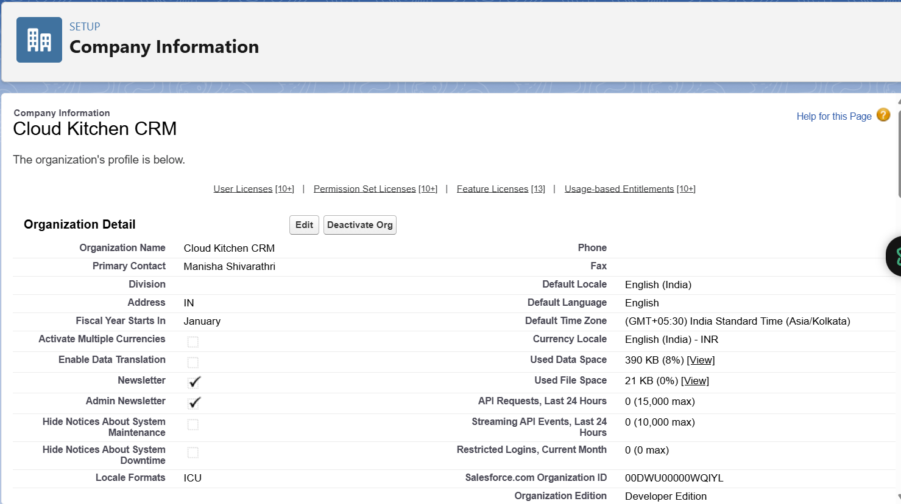

**3. Business Hours & Holidays**   
 ● Kitchens may operate late nights (e.g., 11am–2am).   
 ● Define holidays (if kitchens close on certain festivals).

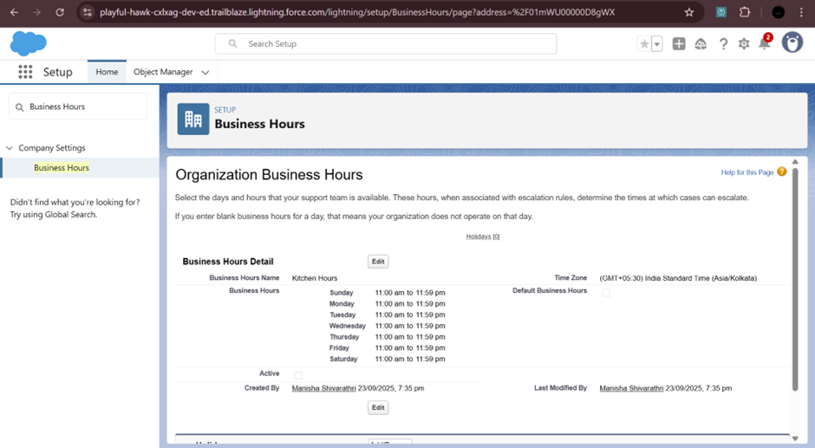

**4. User Setup & Licenses**   
 ● Create users: Admin, Kitchen Manager, Chef, Delivery Partner, Support Agent.   
 ● Assign Salesforce licenses as needed.

**5. Profiles**   
 ● Kitchen Manager: Full access to orders and inventory.   
 ● Chef: Update cooking status only.   
 ● Delivery Partner: View assigned deliveries.   
 ● Support Agent: Handle customer issues.   
 ● Admin: Full system control.

**6. Roles**   
 ● Admin → Kitchen Manager → Staff (Chefs, Delivery Partners) → Support.

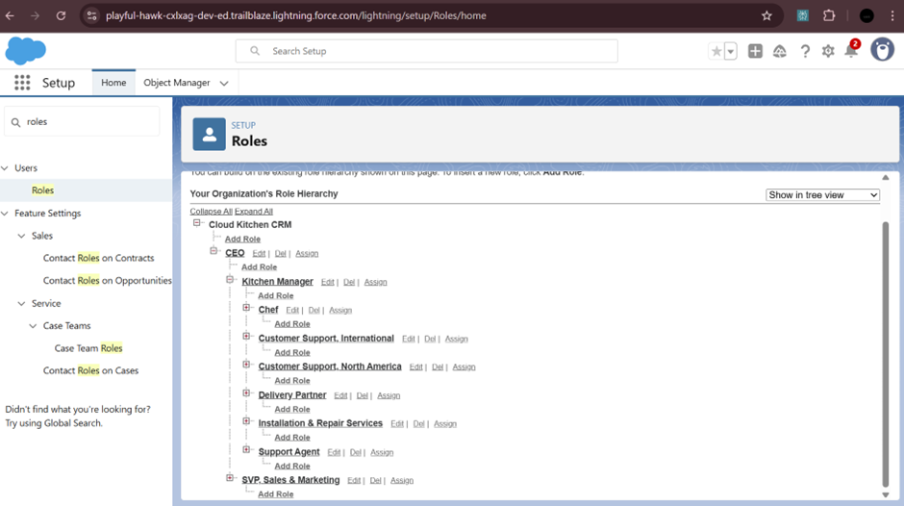

**7. Permission Sets**   
 ● Example: Give Delivery Partners mobile access without changing their profile.



**8. Org-Wide Defaults (OWD)**   
 ● Orders: Private (visible only to assigned staff).   
 ● Menu Items/Inventory: Public Read Only.

**9. Sharing Rules** ● Allow Kitchen Managers to view all orders across branches.

**10. Login Access Policies**   
 ● Restrict staff logins to specific working hours.

**Phase 3: Data Modeling & Relationships**

Goal: Build the data structure for the Cloud Kitchen CRM.

**1. Standard & Custom Objects :**   
 ● Standard: Contact (Customer).   
 ● Custom: Menu Item, Inventory Item, Kitchen Order, Order Item,   
 Delivery Assignment.

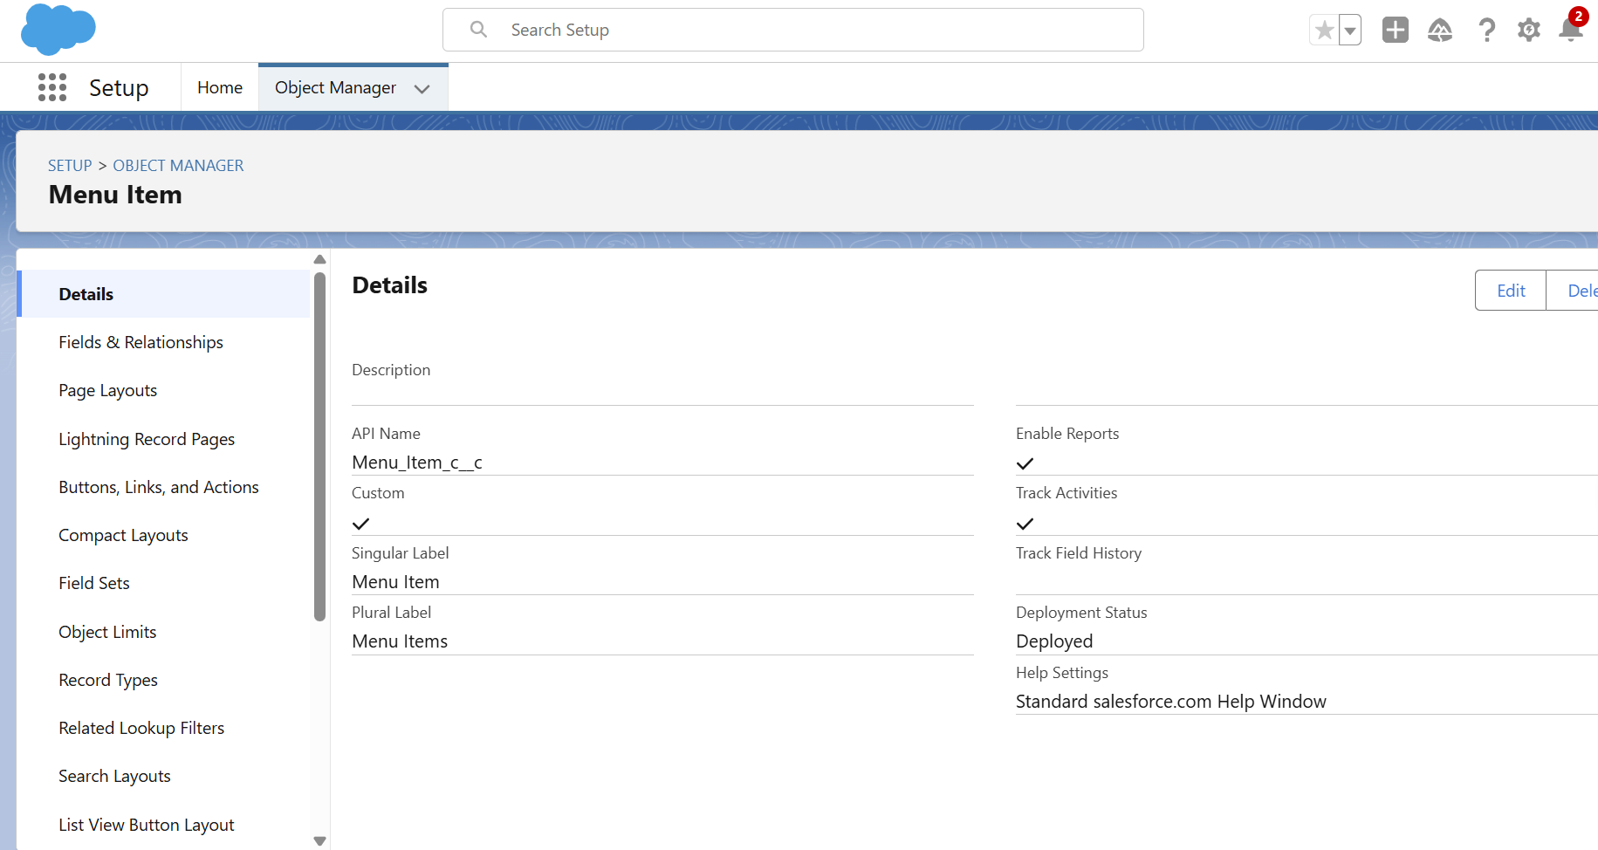

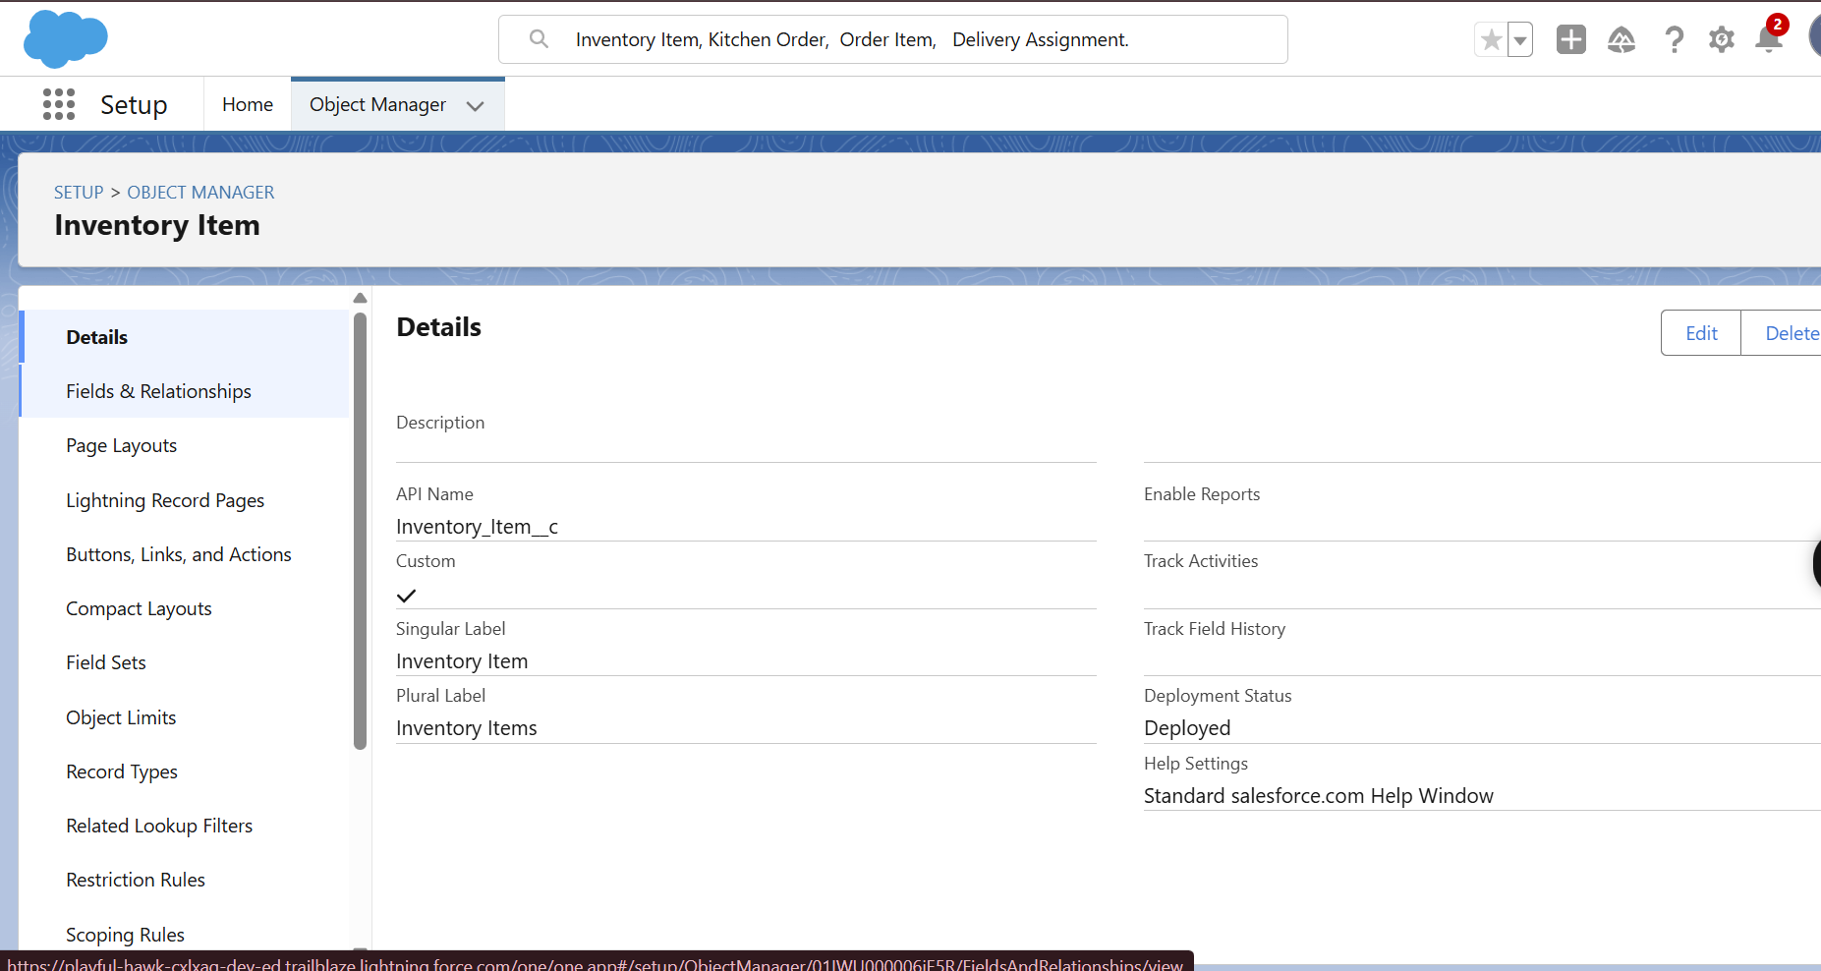

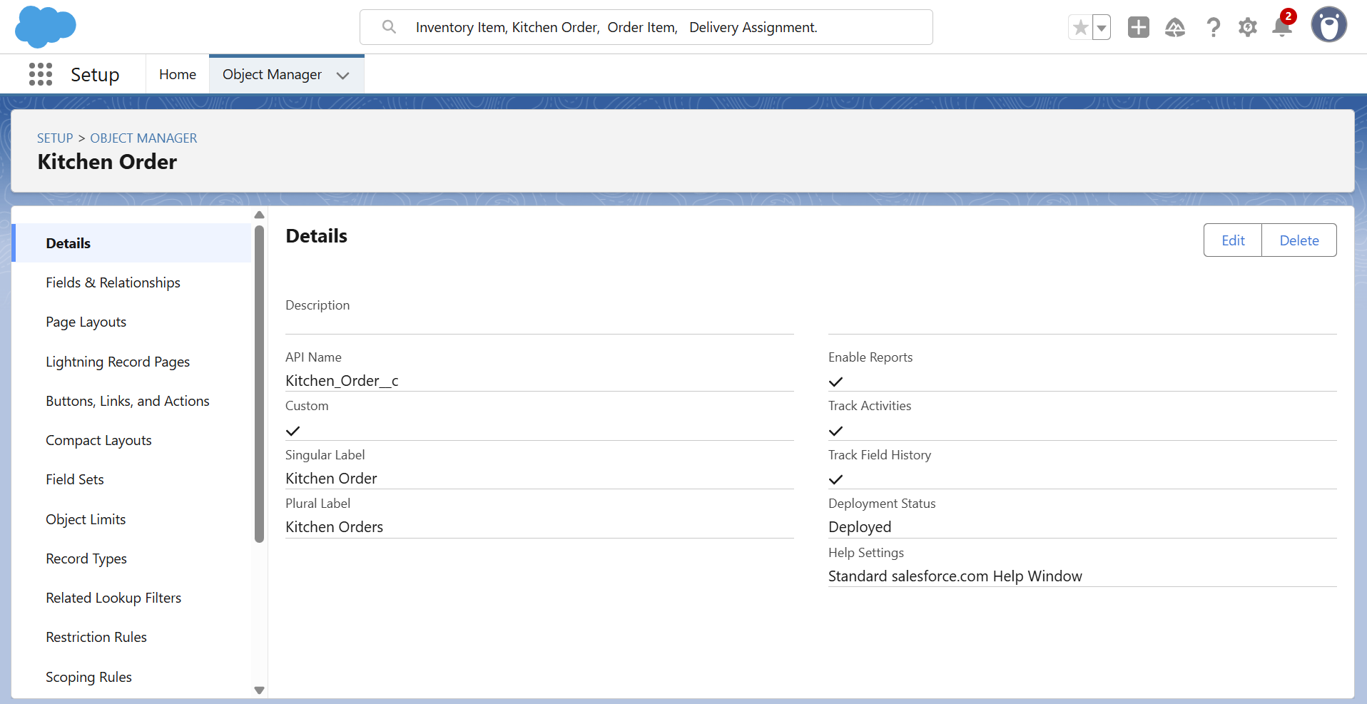

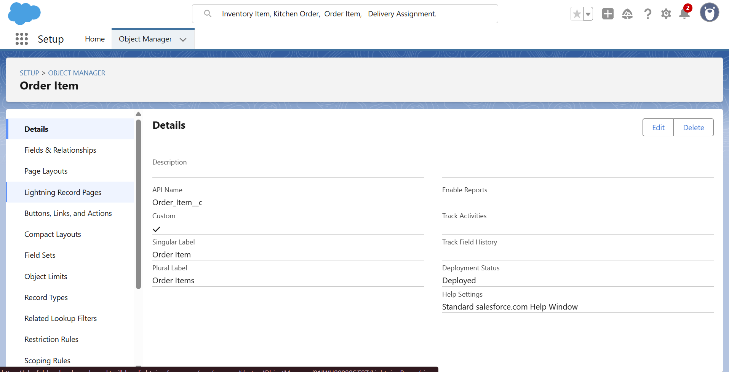

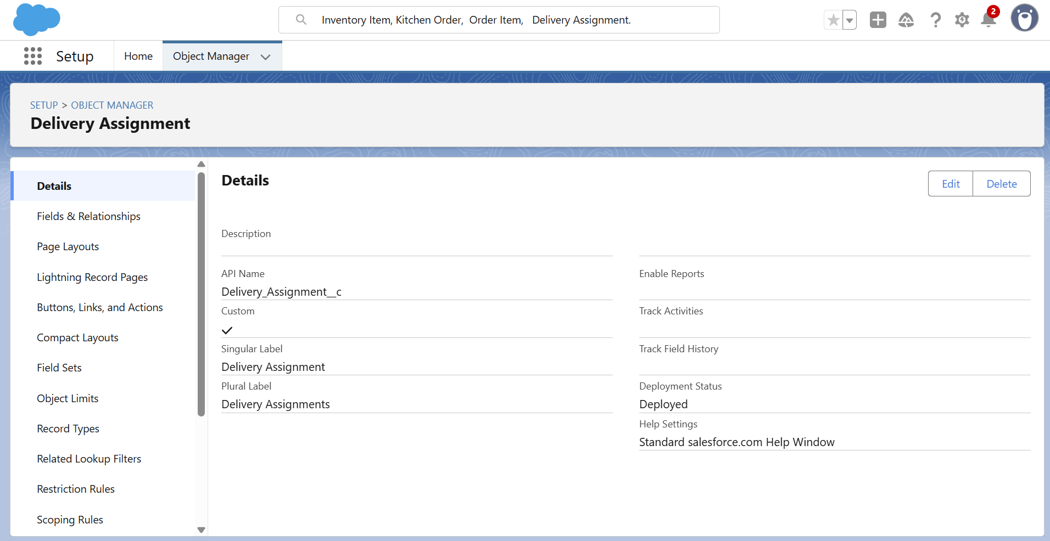

**2. Fields :**   
 • Menu Item : SKU, Price, Prep Time, Category, Active.

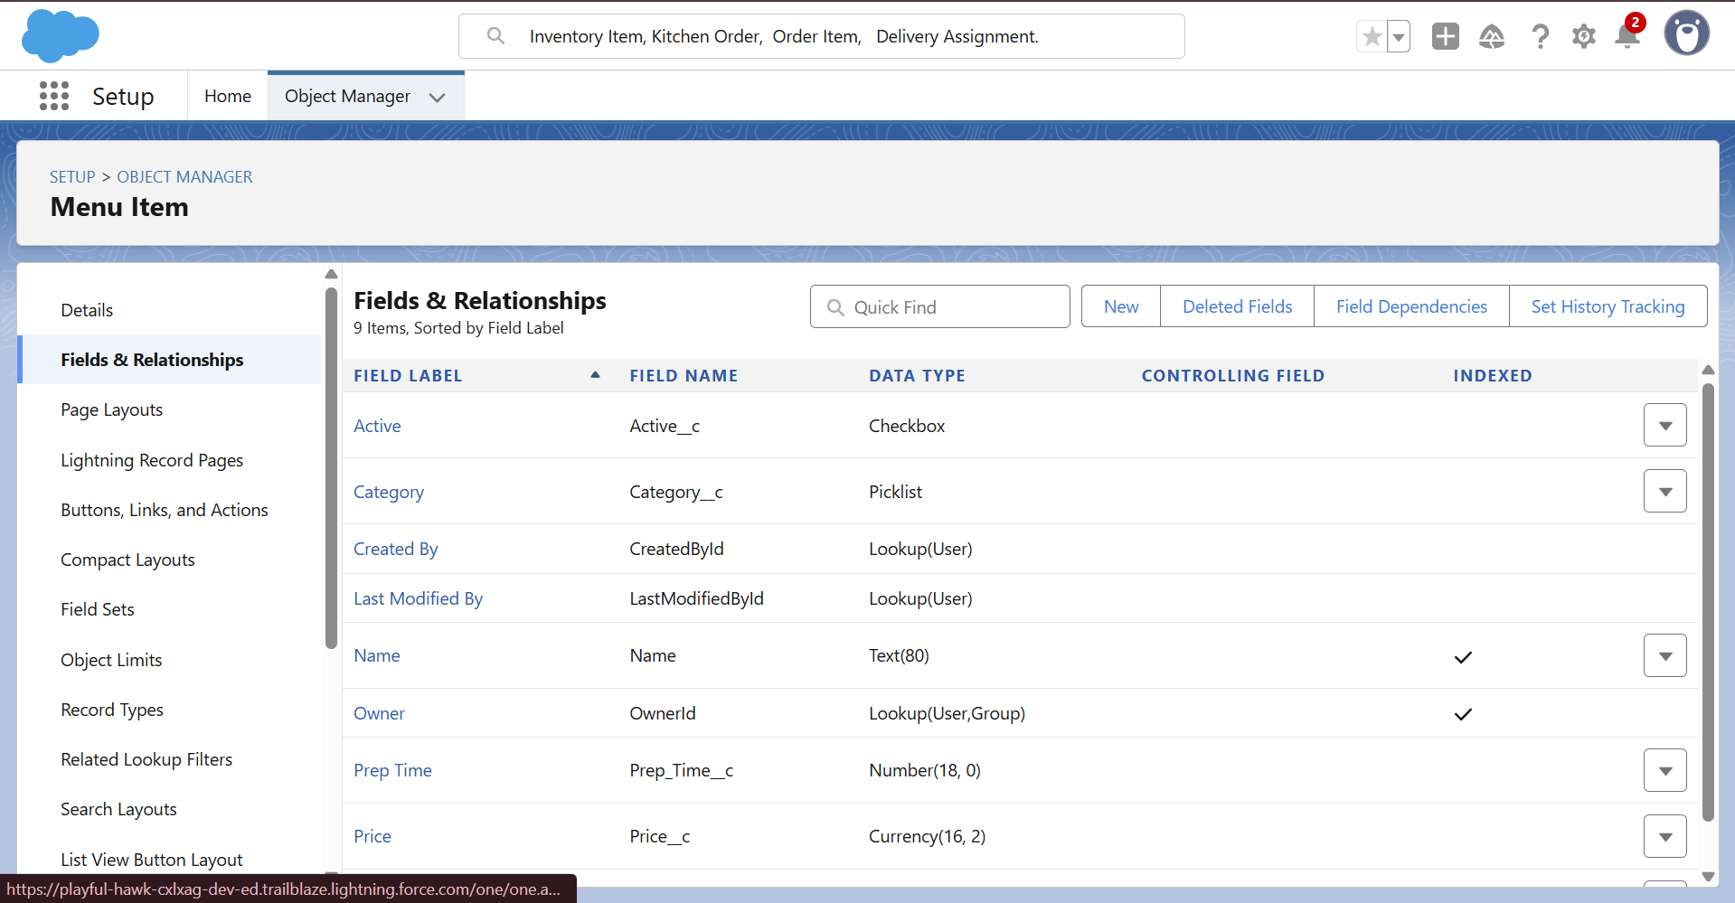  
 • Inventory Item : Quantity On Hand, Reorder Level, Unit, Supplier.

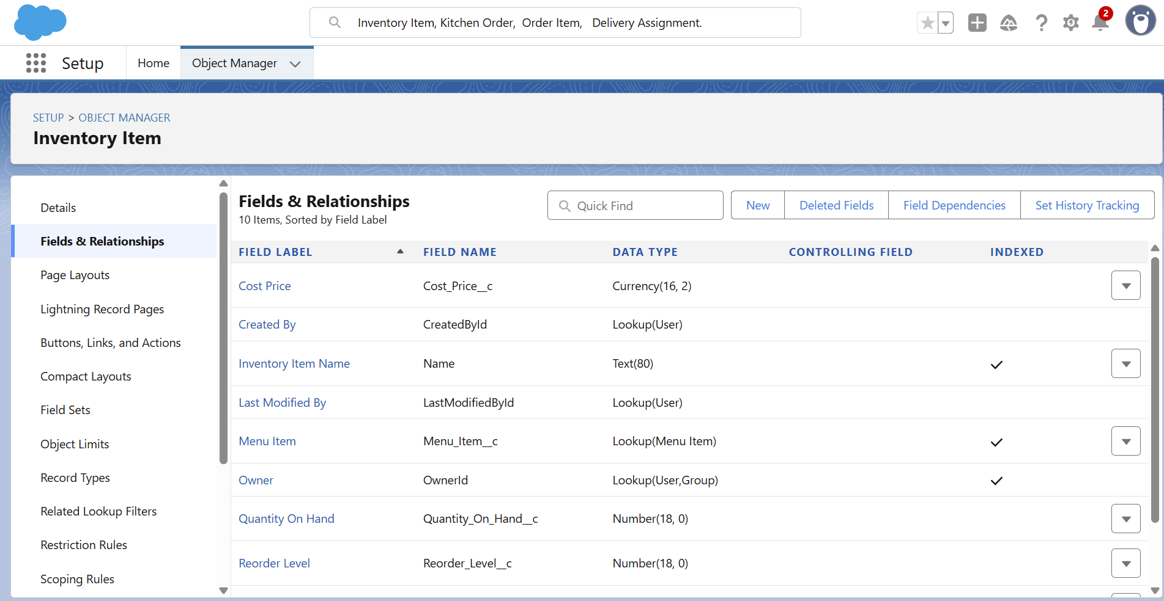  
 • Kitchen Order : Order Number, Customer, Order Date, Delivery Date,   
 Status, Channel, Total Amount.

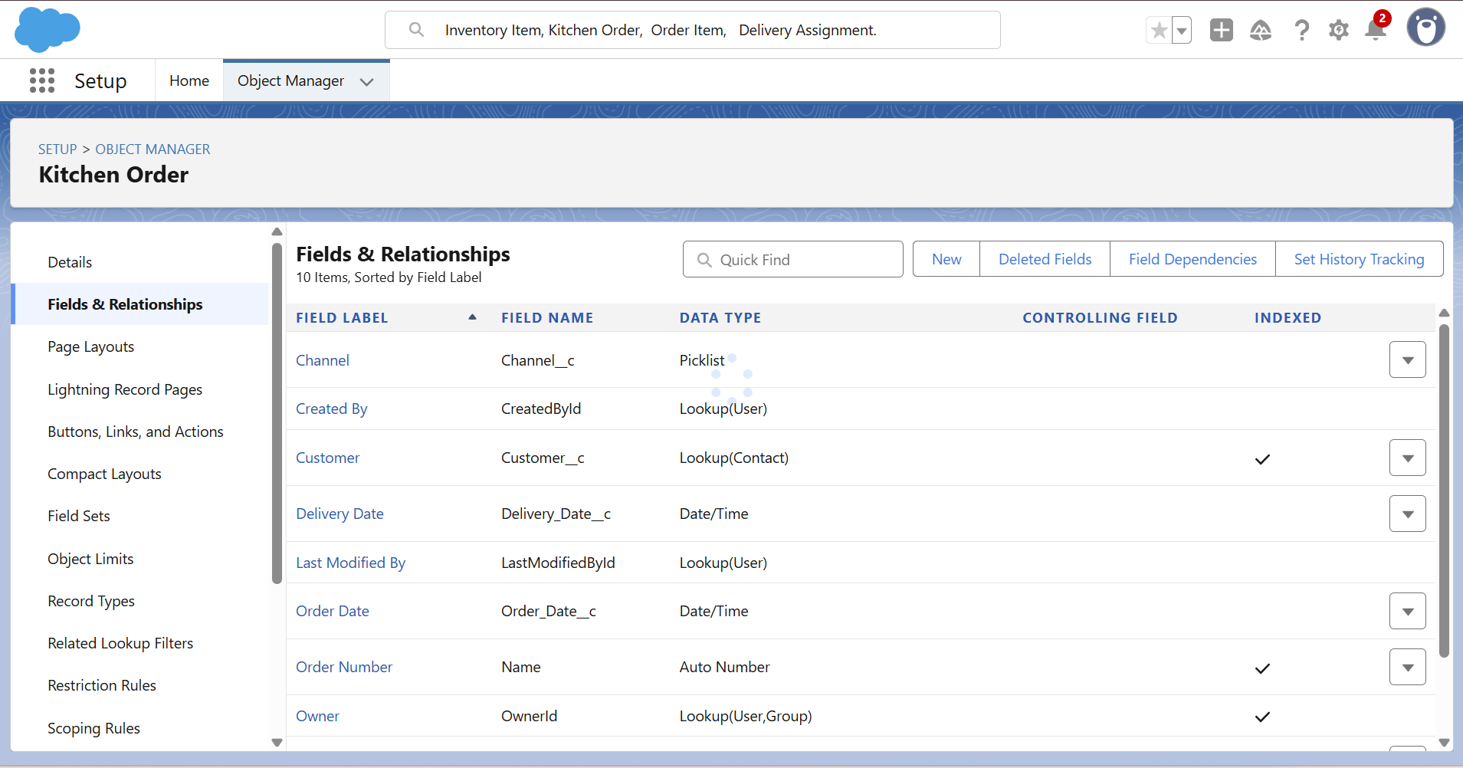  
  
 • Order Item : Quantity, Unit Price, Line Amount (Formula = Quantity * Unit Price) .

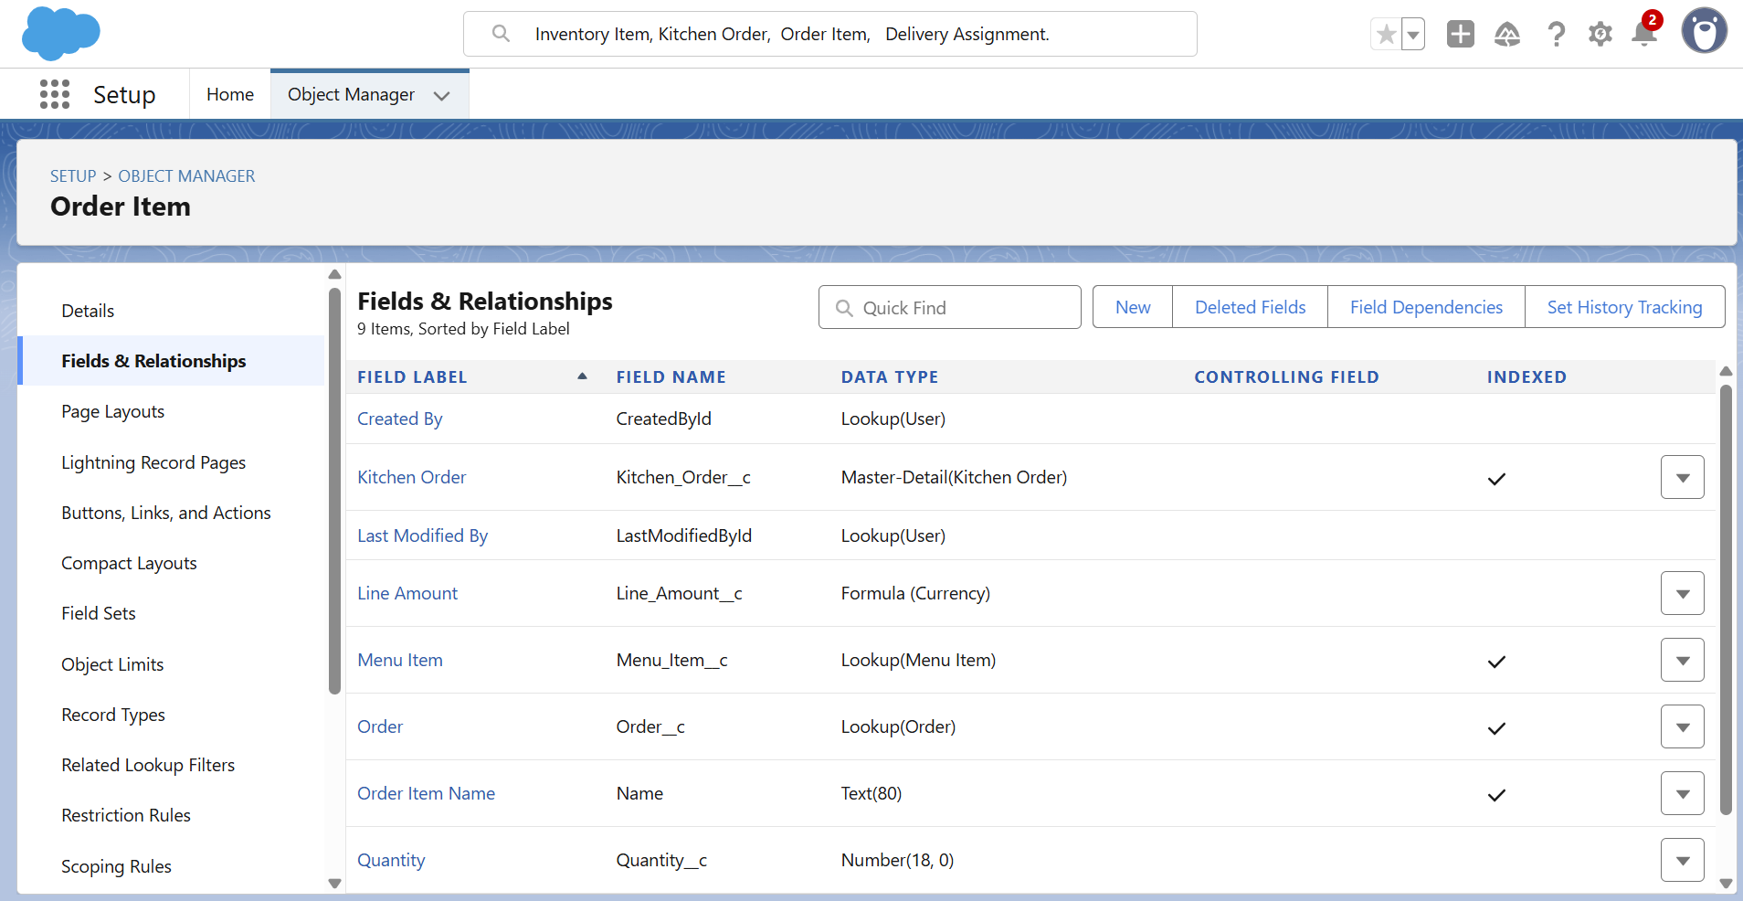  
 • Delivery Assignment: Pickup Time, Delivery Time, Status .

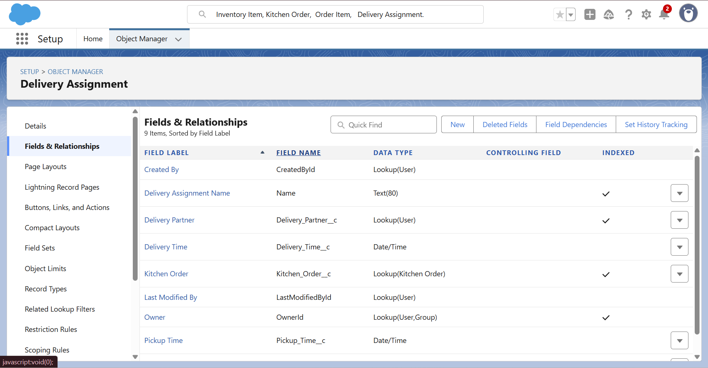

**3. Page Layouts :**   
 • Kitchen Order page : Shows associated Order Items & Delivery   
 Assignment information related lists.

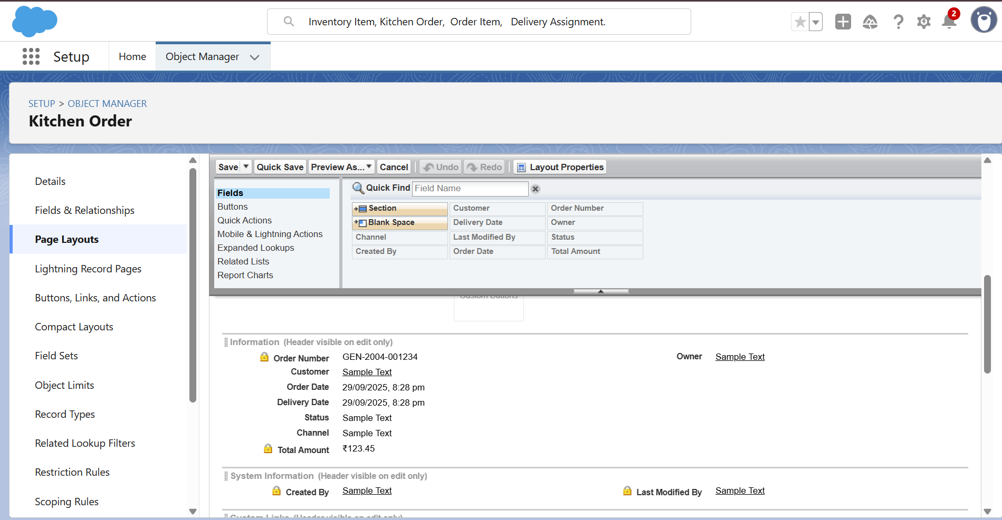

• Menu Item page : shows related Order Items.

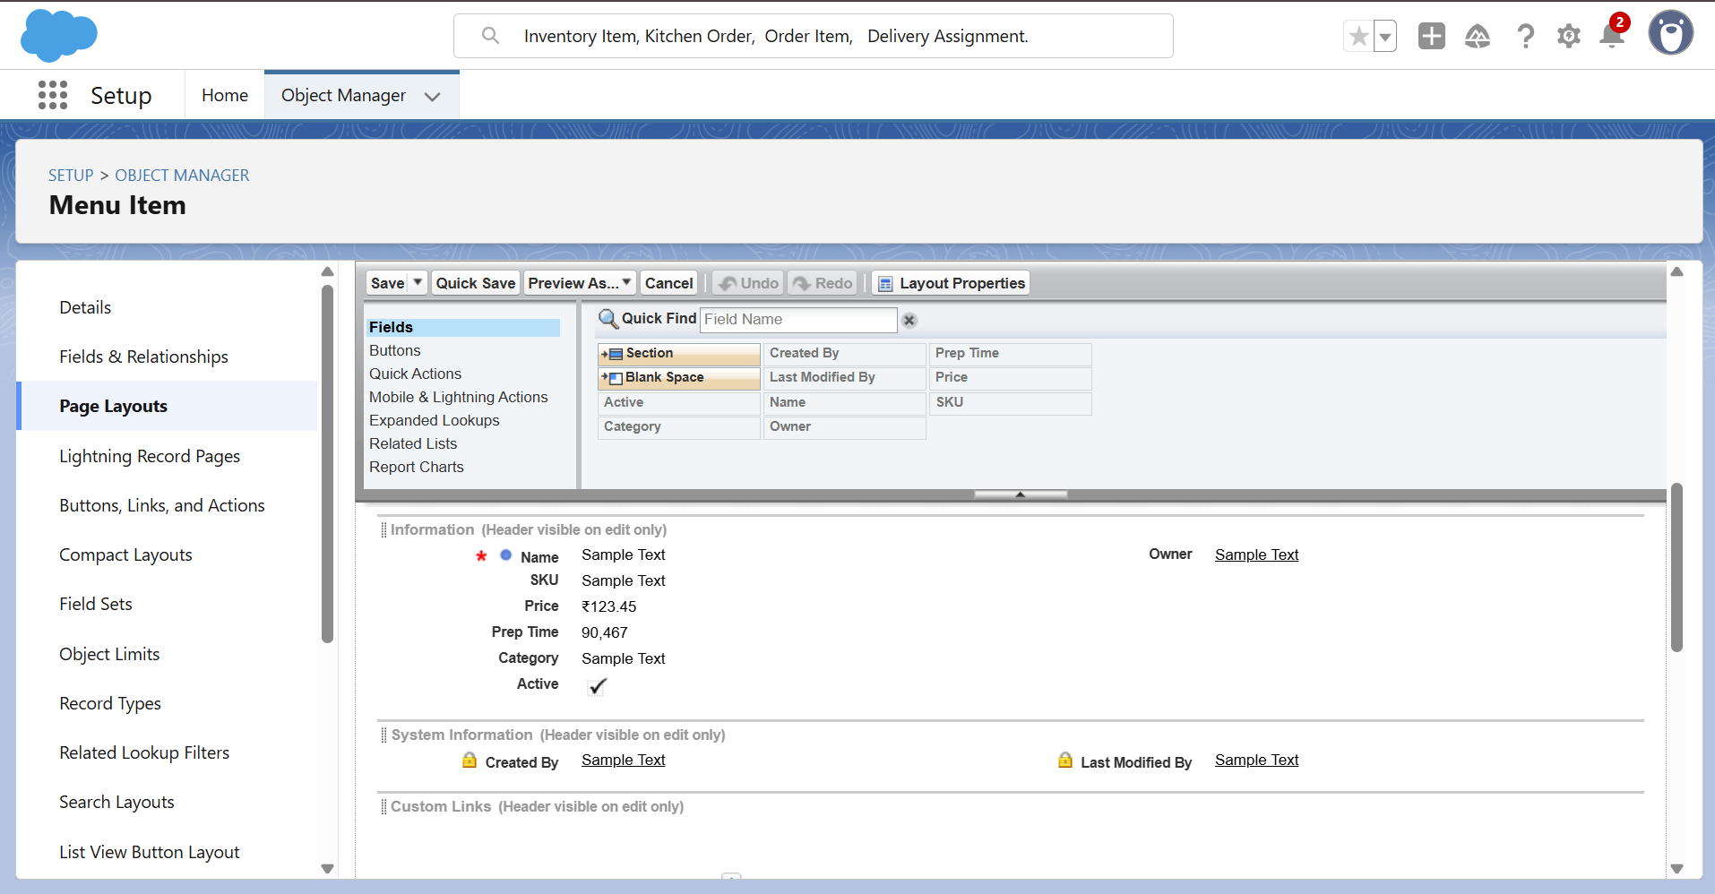

• Inventory Item page : shows stock details (Quantity, Reorder Level).

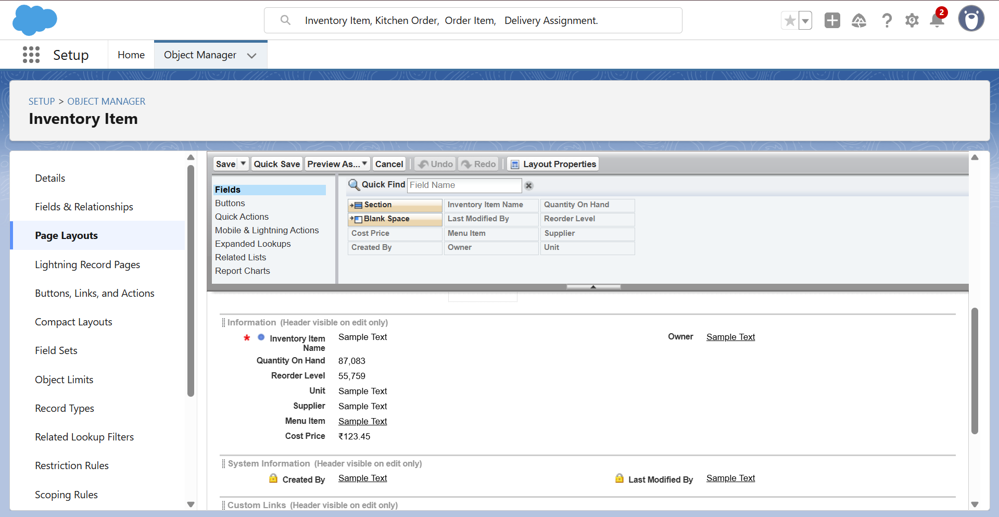

**4. Compact Layouts :** • Kitchen Order (mobile): Order Number, Status, Total Amount.

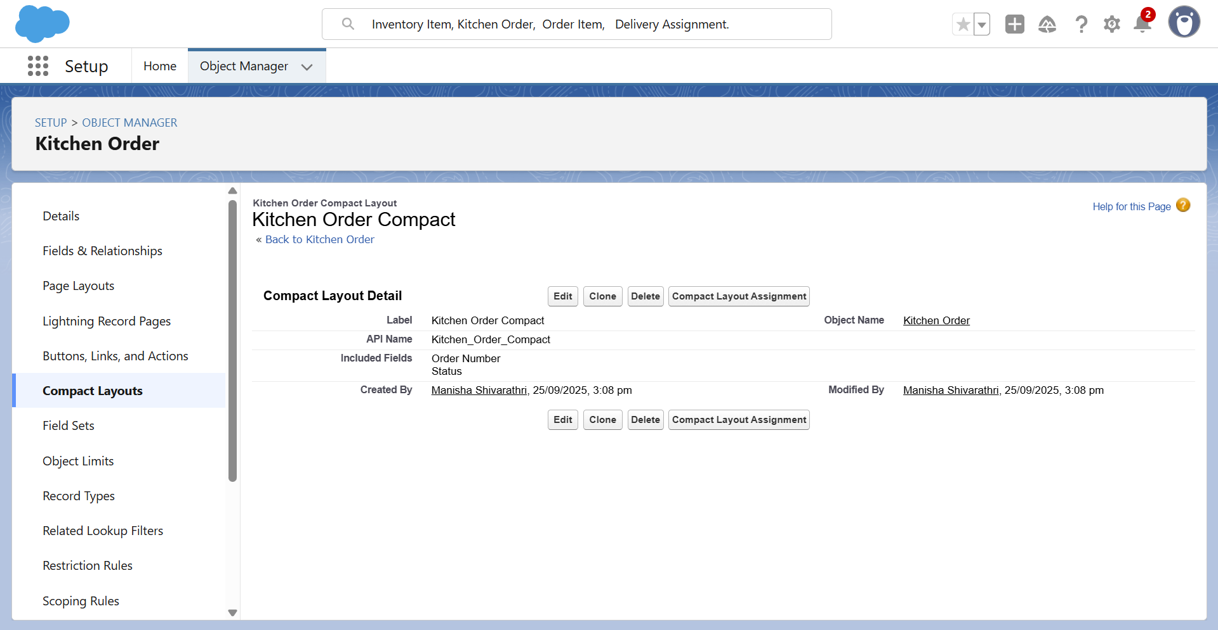

**6 . Schema Builder** :   
 • Visual diagram : Kitchen Order ↔ Order Item ↔ Menu Item ↔   
 Inventory.   
 • Delivery Assignment ↔ Kitchen Order & Delivery Partner (User).

**7. Lookup vs Master-Detail vs Hierarchical :**   
 • Order Item → Kitchen Order: Master-Detail.   
 • Order Item → Menu Item: Lookup.   
 • Delivery Assignment → Kitchen Order: Lookup.   
 • Delivery Assignment → User (Delivery Partner): Lookup.

**8. External Objects:** • Could be used if Supplier inventory or delivery tracking comes from an external ERP/Database.

**Phase 4: Business Logic & Automation**

**Objective:** Automate order-related processes to ensure accuracy and efficiency in the Cloud Kitchen CRM.

**Key Implementations:**

1. **Validation Rules**
   * Example: Ensure Quantity > 0.
   * Prevent saving an order if **Customer Name** or **Status** is missing.
2. **Formulas & Roll-Up Fields**
   * Formula fields for **Line Amount** = Quantity × Unit Price.
   * Roll-Up Summary on Orders to calculate **Total Amount** from related Order Items.
   * 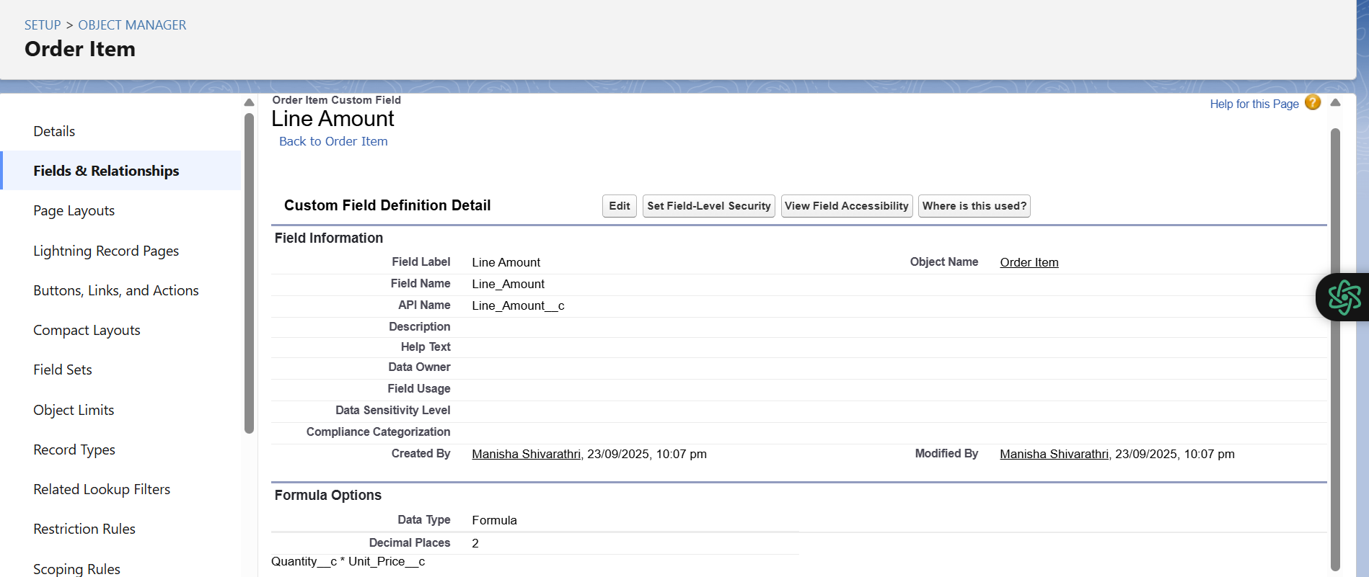
   * 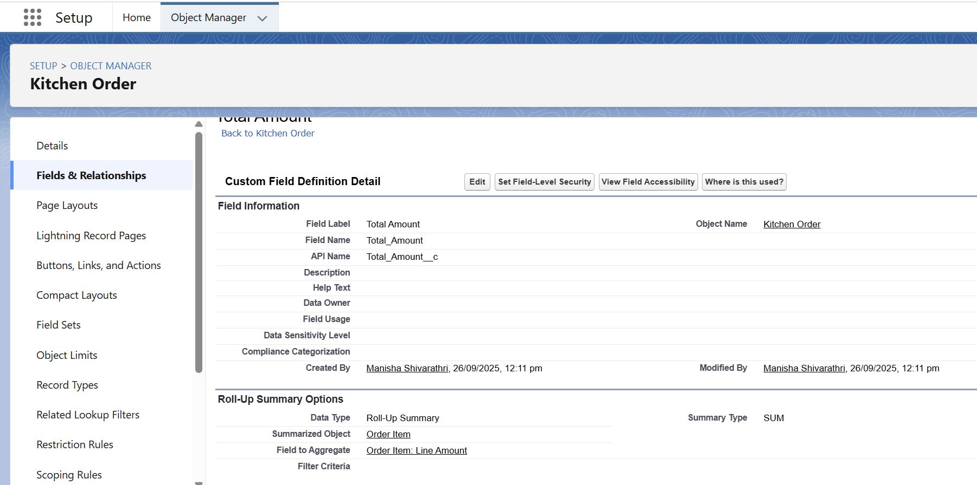
3. **Record-Triggered Flows**
   * Flow triggered when Order Item is created/updated → updates **Order Total** automatically.
   * Ensures no manual recalculation needed.
   * 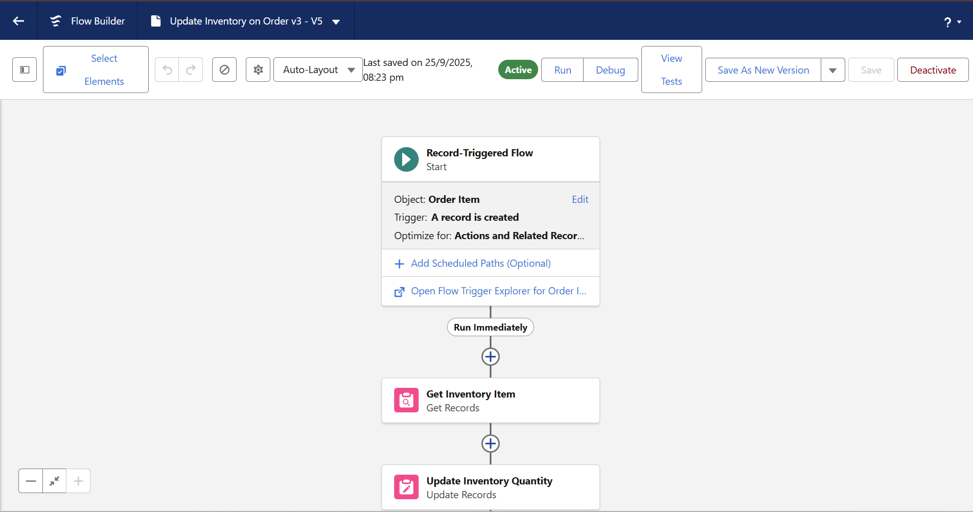
4. **Process Automation Benefits**
   * Reduces errors.
   * Saves staff time.
   * Provides consistent data for reports and dashboards.

**Phase 5: Apex Programming**

In this phase, I implemented Apex programming concepts to enhance Salesforce functionality and automate order management processes.

1. **Apex Classes**  
   Created classes like **OrderHelper** to handle order calculations, discounts, and taxes in a reusable and consistent manner.
2. **Apex Triggers**  
   Developed triggers on **Order** and **Order Item** objects (before/after insert, update, delete) to automatically update order totals and maintain data integrity.
3. **SOQL Queries**  
   Used dynamic **SOQL** queries to fetch order and menu data, ensuring real-time processing and accuracy.
4. **Batch Apex**  
   Implemented **Batch Apex** to efficiently process large datasets, such as recalculating totals across many records.
5. **Queueable Apex**  
   Utilized **Queueable Apex** for asynchronous processing of order updates, improving performance and user experience.
6. **Outcome**  
   These enhancements automated calculations, handled large data efficiently, and ensured accurate, scalable order management.

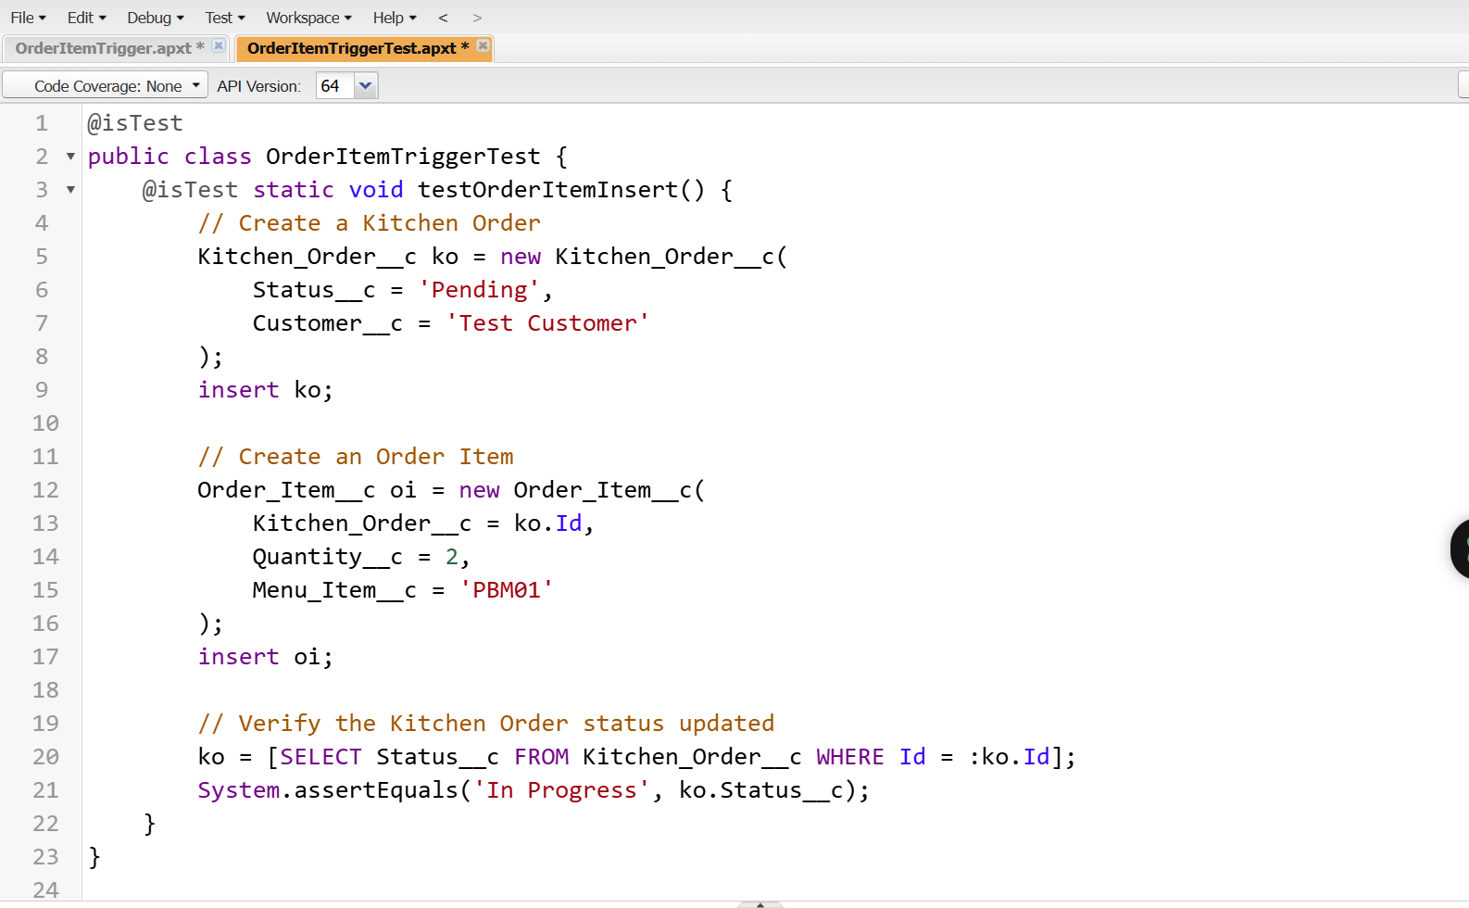

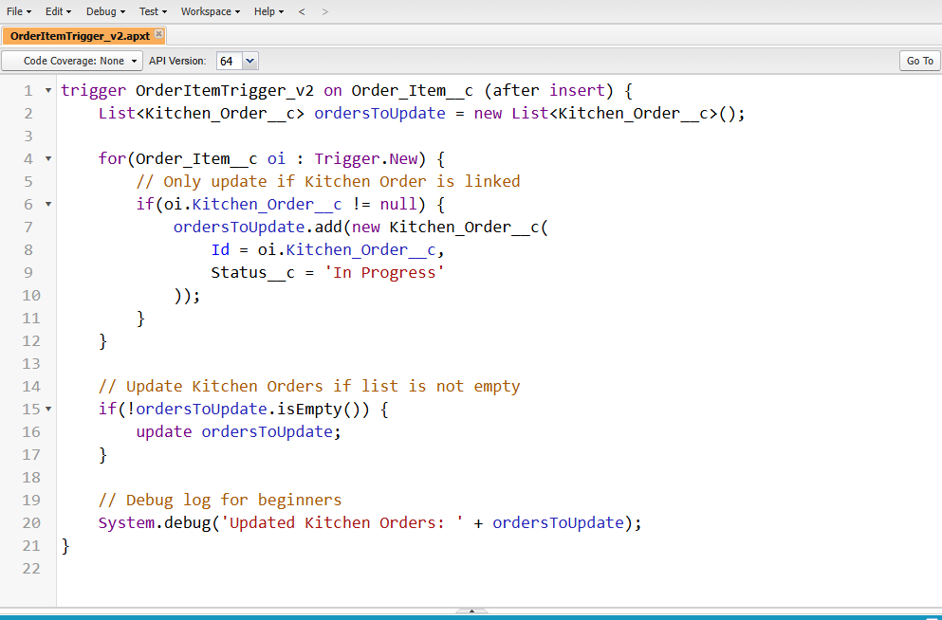

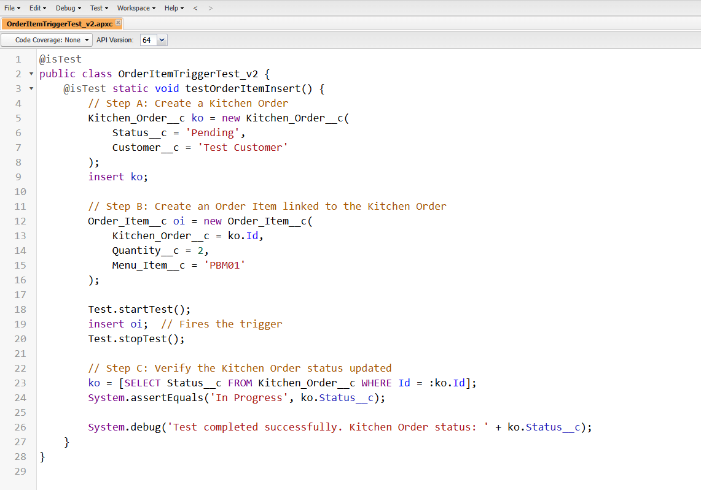

**Phase 6: User Interface Development**

In this phase, the focus was on **enhancing the Salesforce user experience** by customizing the interface to be intuitive, efficient, and visually aligned with business operations. The main objectives were to make navigation seamless, display critical information clearly, and provide users with a productive workspace for daily tasks.

**Key Activities:**

1. **Custom App Creation:**
   * A **Kitchen App** was created in the App Manager to consolidate all relevant objects, reports, and dashboards into a single workspace.
   * This improves accessibility and reduces the time spent switching between objects.
2. **Record Page Customization:**
   * Designed tailored **record pages** for **Orders, Menu Items, and Inventory** objects.
   * Important fields and related lists were strategically positioned for quick data entry and retrieval.
3. **Custom Tabs and Navigation:**
   * Added **custom tabs** for core objects within the Kitchen App.
   * Simplifies navigation for users by grouping related objects and processes together.
4. **Home Page Layout Customization:**
   * Configured the **Home Page** to display **dashboards, reports, and key metrics**, providing at-a-glance insights into kitchen operations.
   * This helps managers monitor performance and track pending orders or inventory status effectively.
5. **Optional Lightning Web Components (LWCs):**
   * Built **custom UI components** for specialized functionality or visualization not available in standard Salesforce components.
   * Examples include interactive order lists, dynamic status indicators, or quick action buttons.

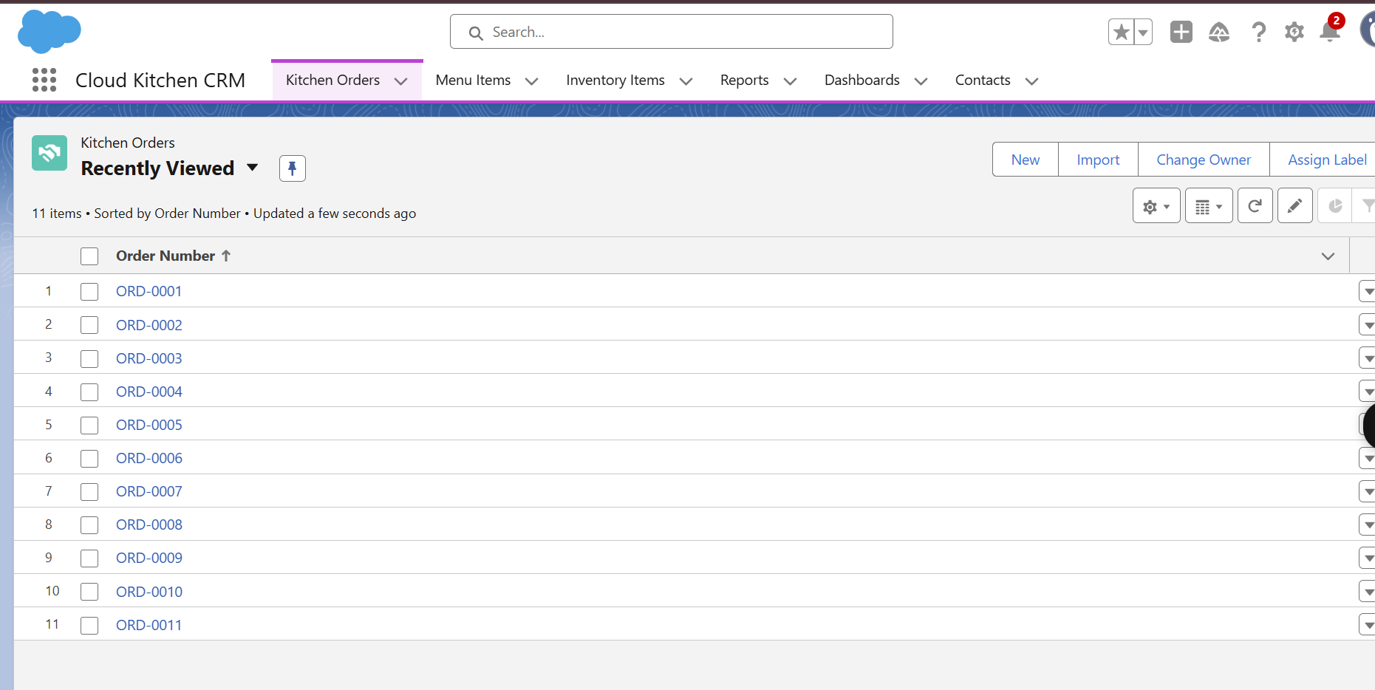

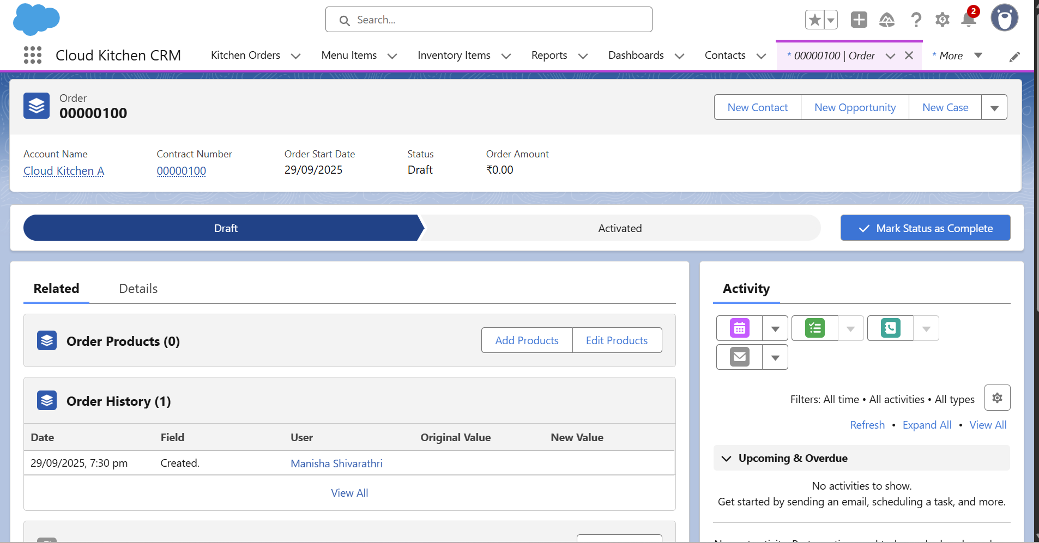

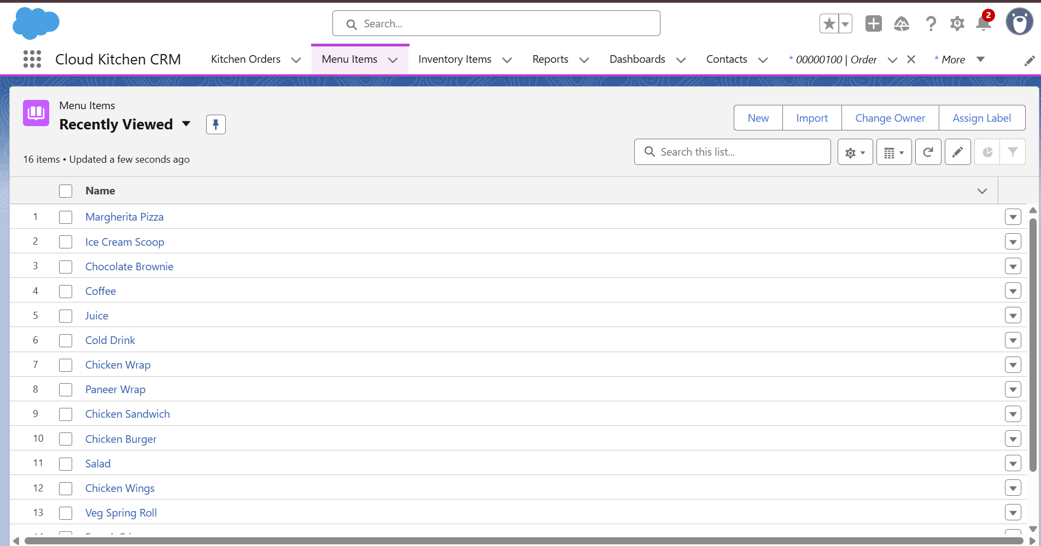

**Phase 7: Integration & External Access**

In this phase, the project focused on **enabling seamless communication between Salesforce and external systems**, as well as configuring Salesforce to handle **real-time events**. Integration and external access are essential for modern applications, allowing data exchange, automated notifications, and real-time updates across platforms.

**Key Activities:**

1. **Named Credentials Setup:**
   * **Named Credentials** were configured to securely store authentication details for external APIs.
   * This allows Salesforce to make callouts without exposing sensitive credentials in Apex code or flows.
   * Using Named Credentials simplifies maintenance, as credentials can be updated centrally without modifying code.
2. **Remote Site Settings Configuration:**
   * Salesforce enforces strict security for HTTP callouts. To allow communication with external endpoints, **Remote Site Settings** were created for approved URLs.
   * This ensures that all API callouts are secure and Salesforce only communicates with trusted external systems.
3. **Platform Events Creation:**
   * **Platform Events**, such as OrderReadyEvent, were created to facilitate **real-time communication** within Salesforce or with external systems.
   * For example, when an order is marked as ready in the Kitchen, the OrderReadyEvent can trigger notifications to delivery personnel, mobile apps, or other integrated systems.
   * Platform Events enable **asynchronous, event-driven architecture**, reducing polling and improving system performance.
4. **Simulated Integration Scenarios:**
   * Test integrations were set up to simulate API callouts and real-time notifications.
   * This helps verify that external systems can securely receive data and respond to Salesforce events.
5. **Security Considerations:**
   * All integrations were configured considering **authentication, encryption, and domain whitelisting**.
   * Named Credentials and Remote Site Settings together ensure that only authorized and verified systems interact with Salesforce.

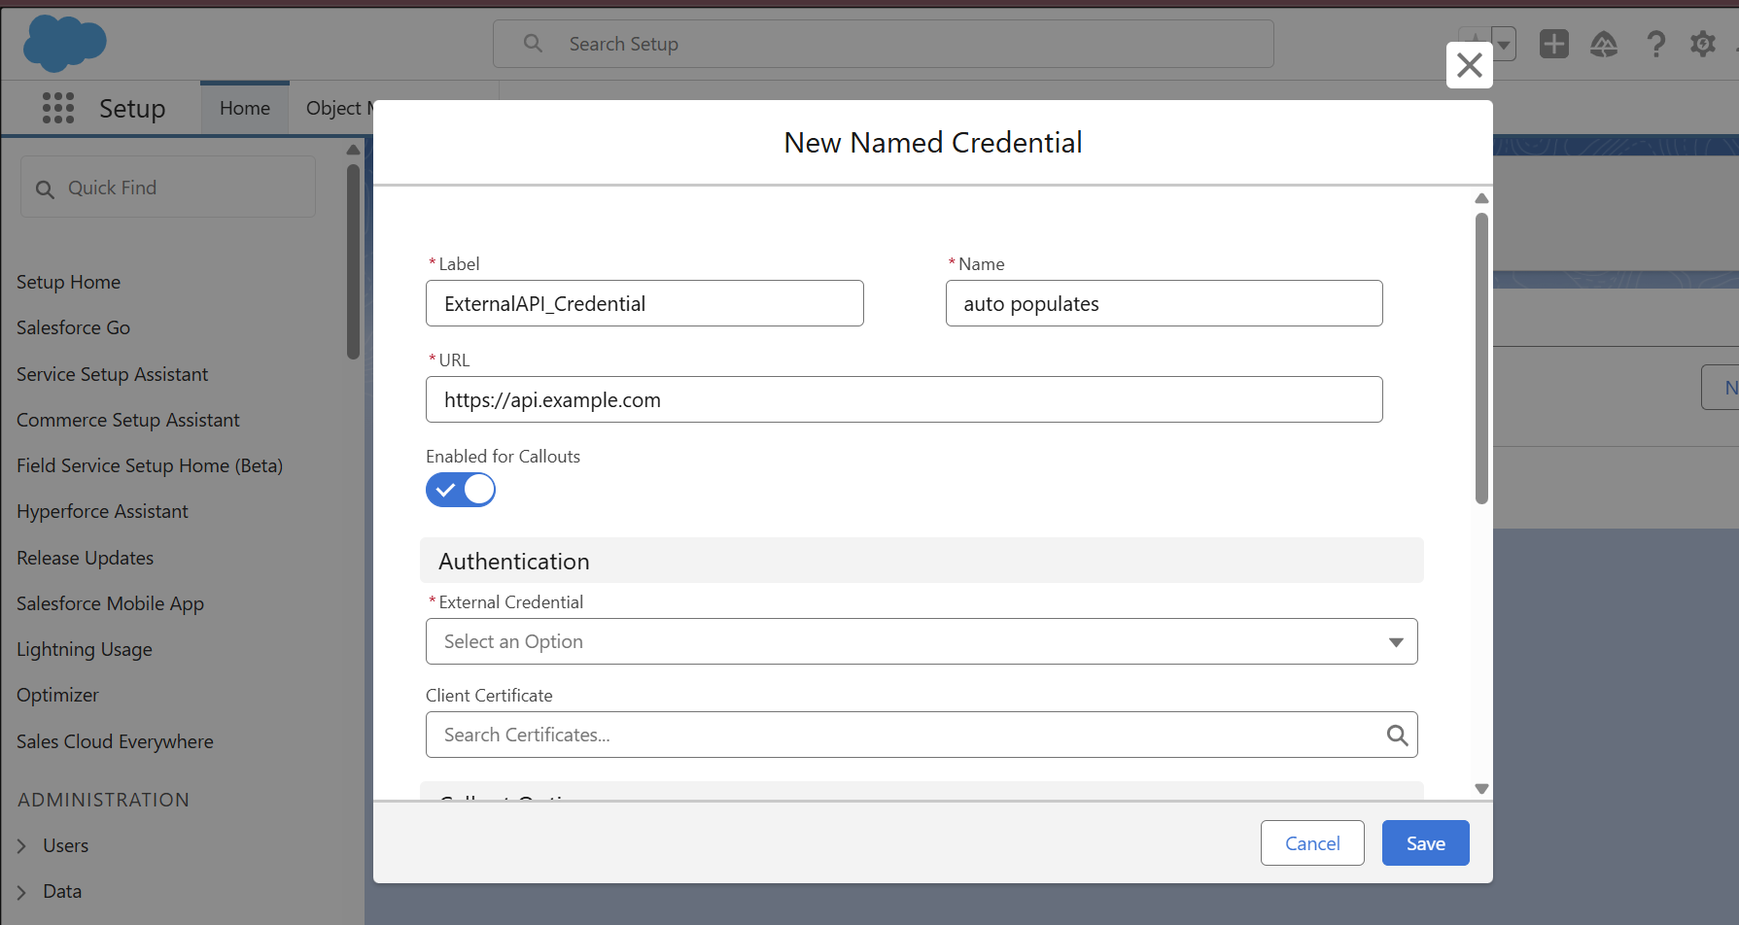

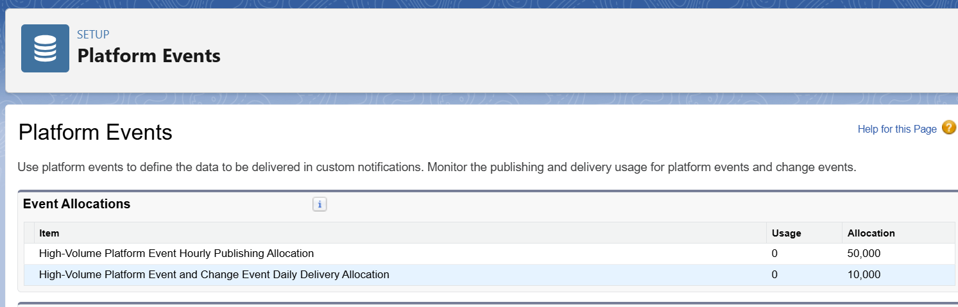

**Phase 8: Reports & Dashboards**

In this phase, **Reports and Dashboards** were implemented to provide **real-time insights into kitchen operations and business performance**. The goal was to enable managers and staff to make **data-driven decisions**, track progress, and identify trends quickly.

**Key Activities:**

1. **Report 1: Daily Orders by Status**
   * A **summary report** was created on the **Orders object**, grouped by **Order Status**.
   * This report allows the kitchen team and management to **monitor daily order flow**, track pending, in-progress, and completed orders, and ensure timely preparation and delivery.
   * Filters such as **Order Date = Today/This Week** can be applied to view specific time periods.
2. **Report 2: Revenue by Menu Item**
   * A report was created to **analyze revenue by individual menu items**.
   * Grouped by **Menu Item** and using **SUM(Line Amount)** to calculate total revenue per item.
   * This helps management identify **best-selling items**, plan inventory, and optimize menu offerings.
3. **Kitchen Dashboard Creation**
   * A **Lightning Dashboard** named **Kitchen Dashboard** was created to visually display key metrics.
   * Components include:
     + **Bar Chart:** Daily Orders by Status, showing the count of orders per status.
     + **Pie Chart:** Revenue distribution by Menu Item.
   * Dashboards provide a **high-level overview** for managers, enabling quick identification of bottlenecks or popular menu items.
4. **Practical Benefits:**
   * Facilitates **quick decision-making** for inventory and staffing.
   * Enables **performance tracking** against daily targets.
   * Provides **visual insights** that are easier to interpret than raw data tables.

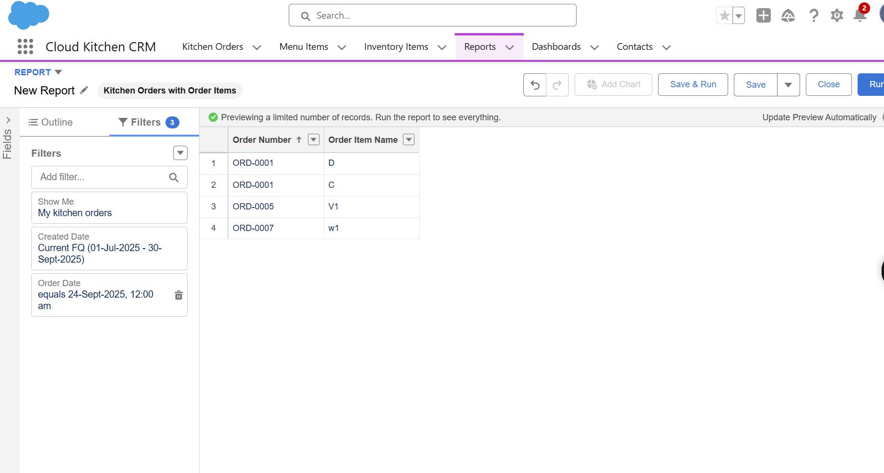

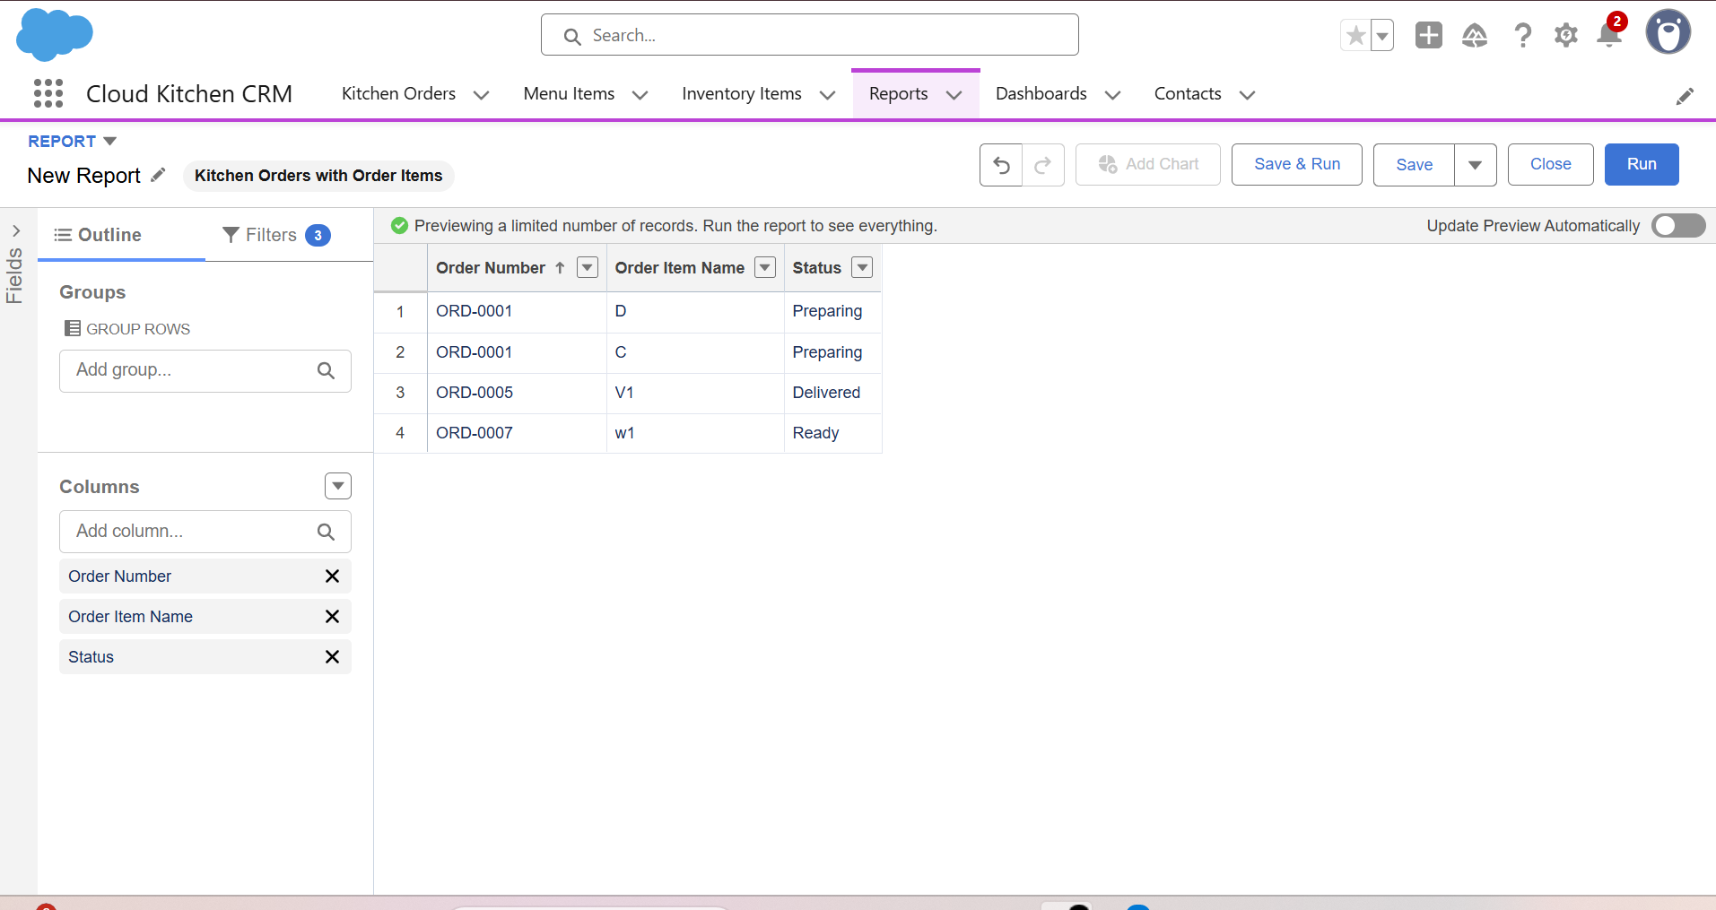

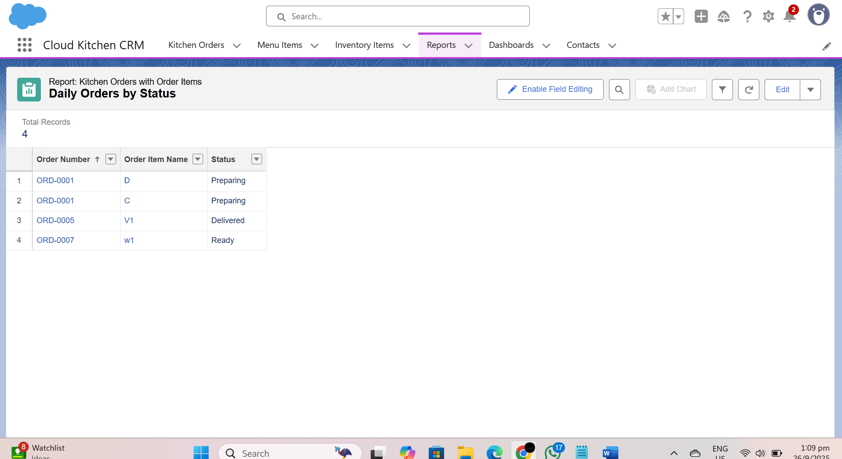

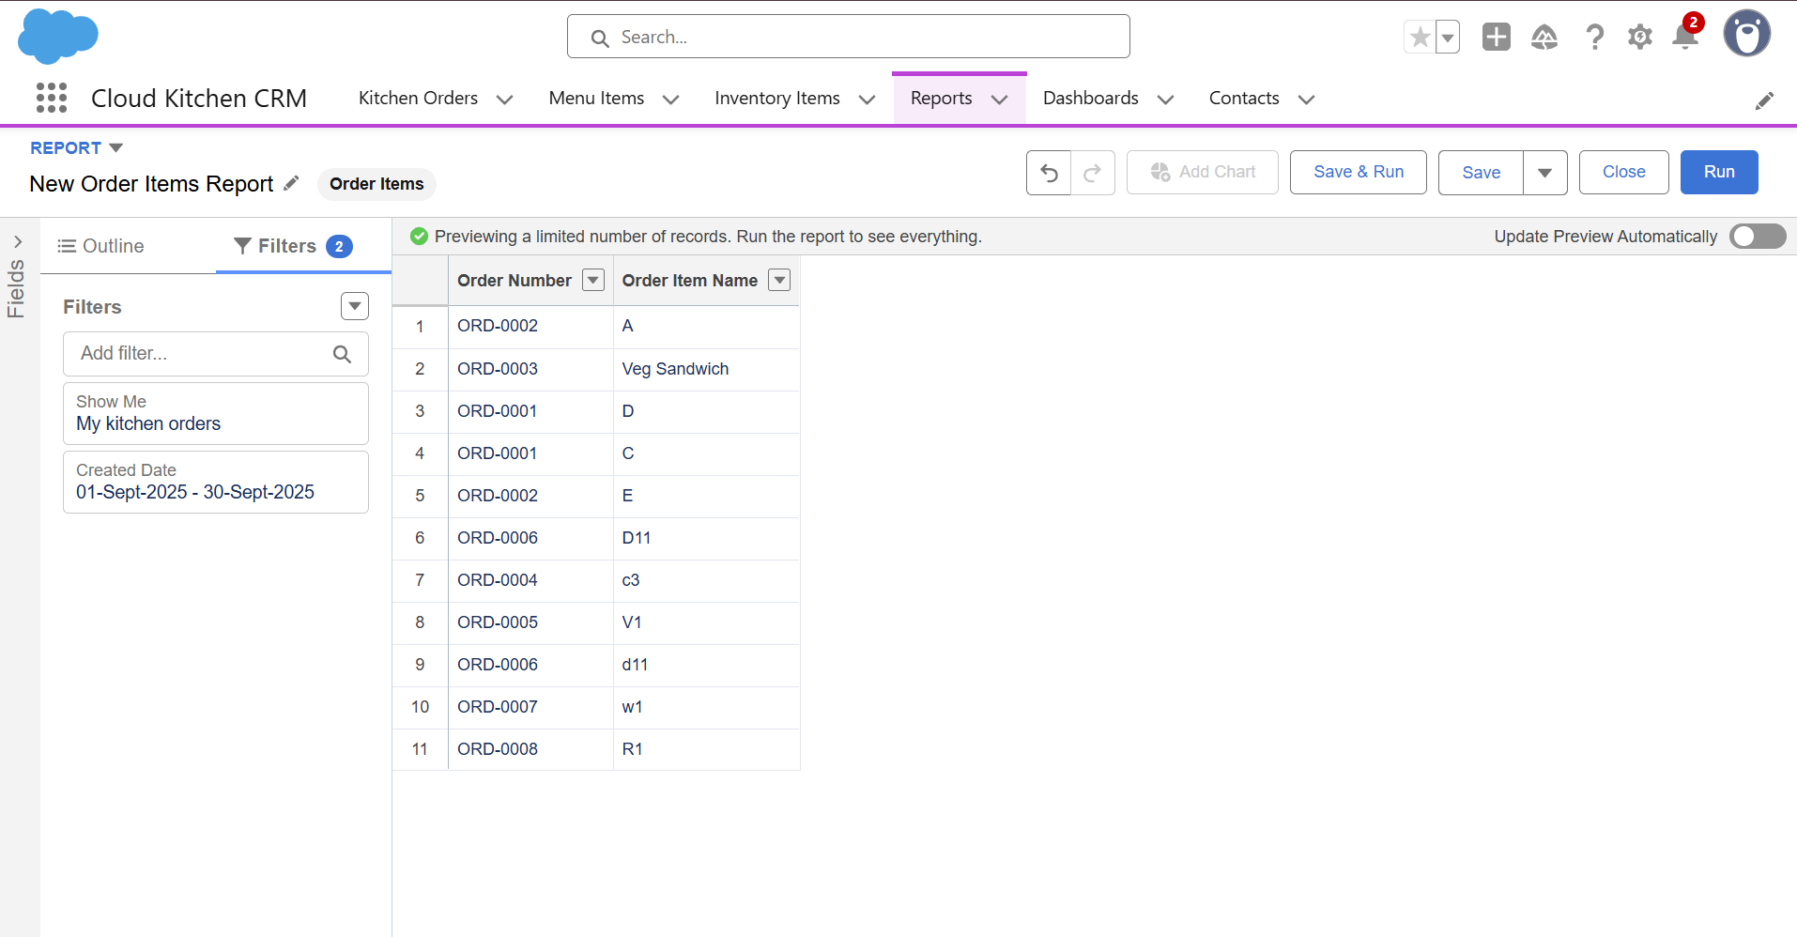

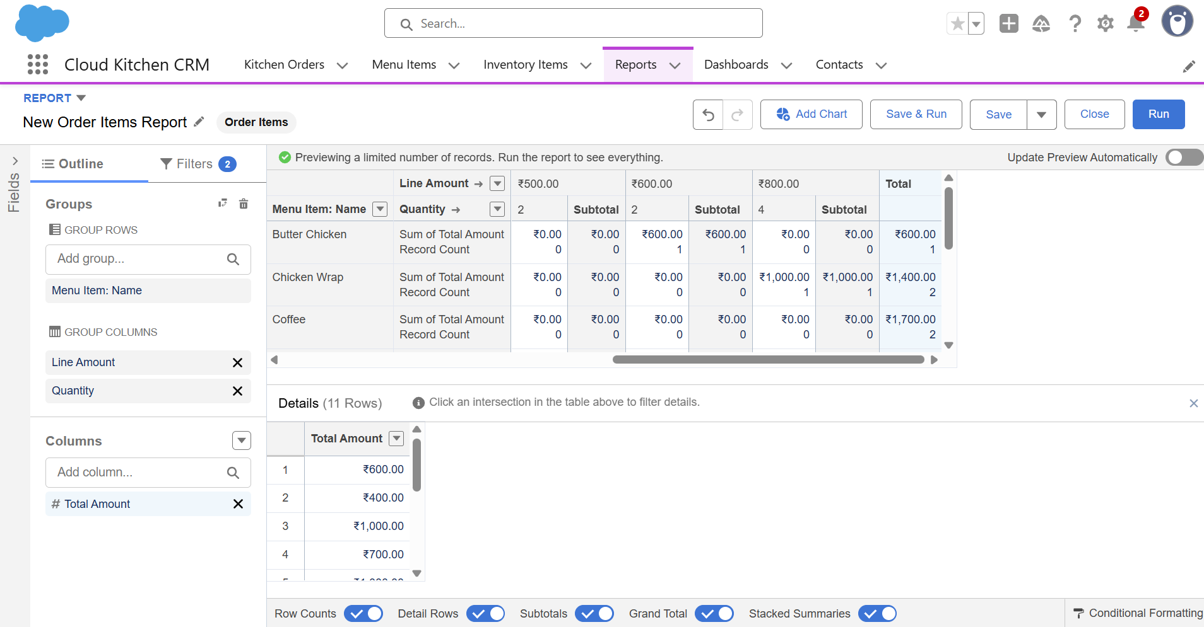

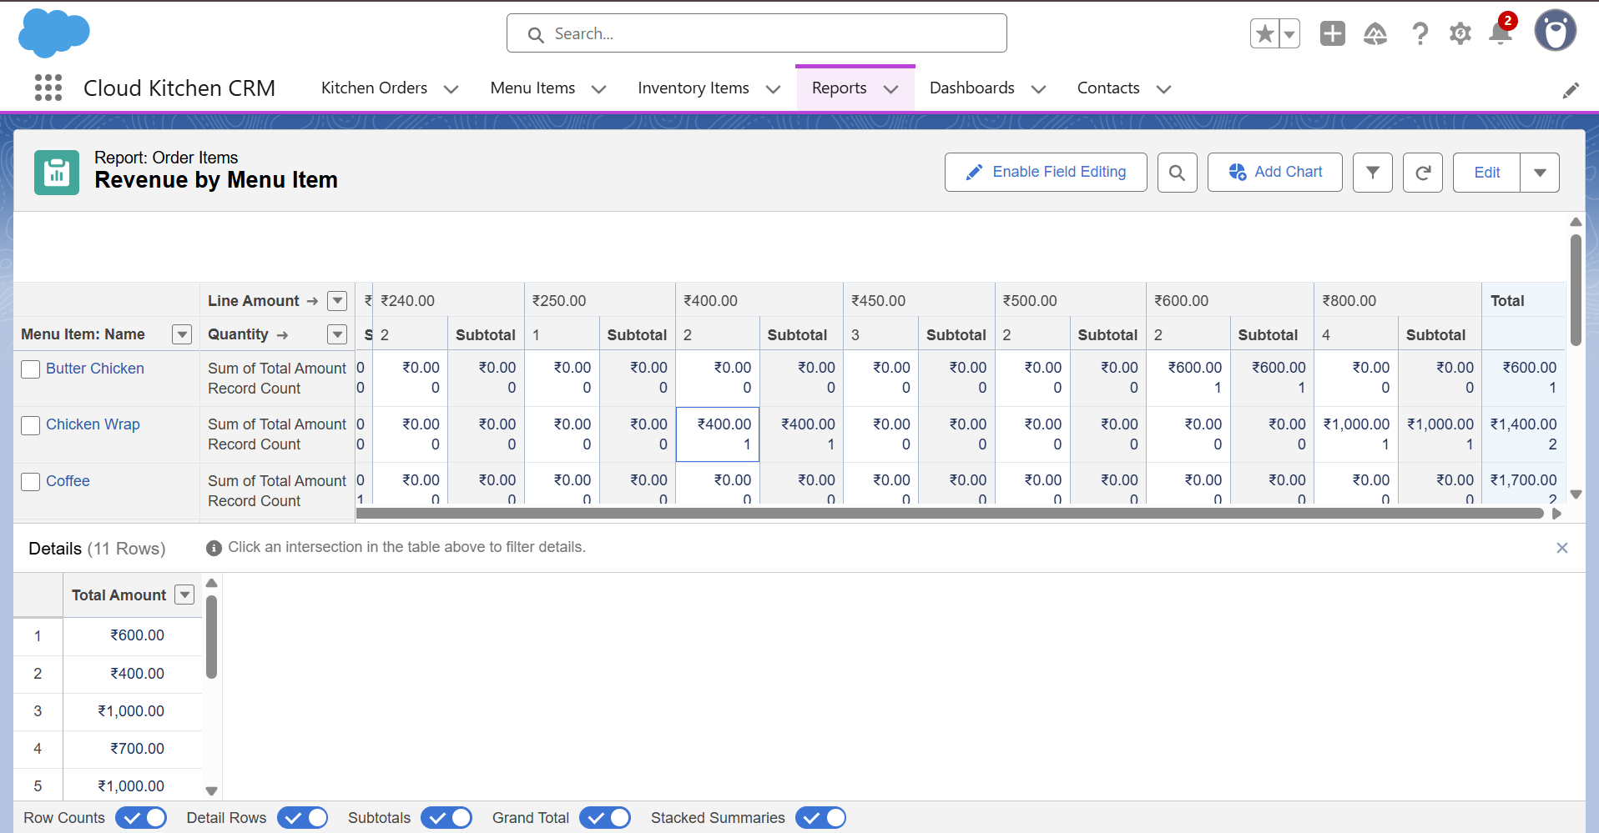

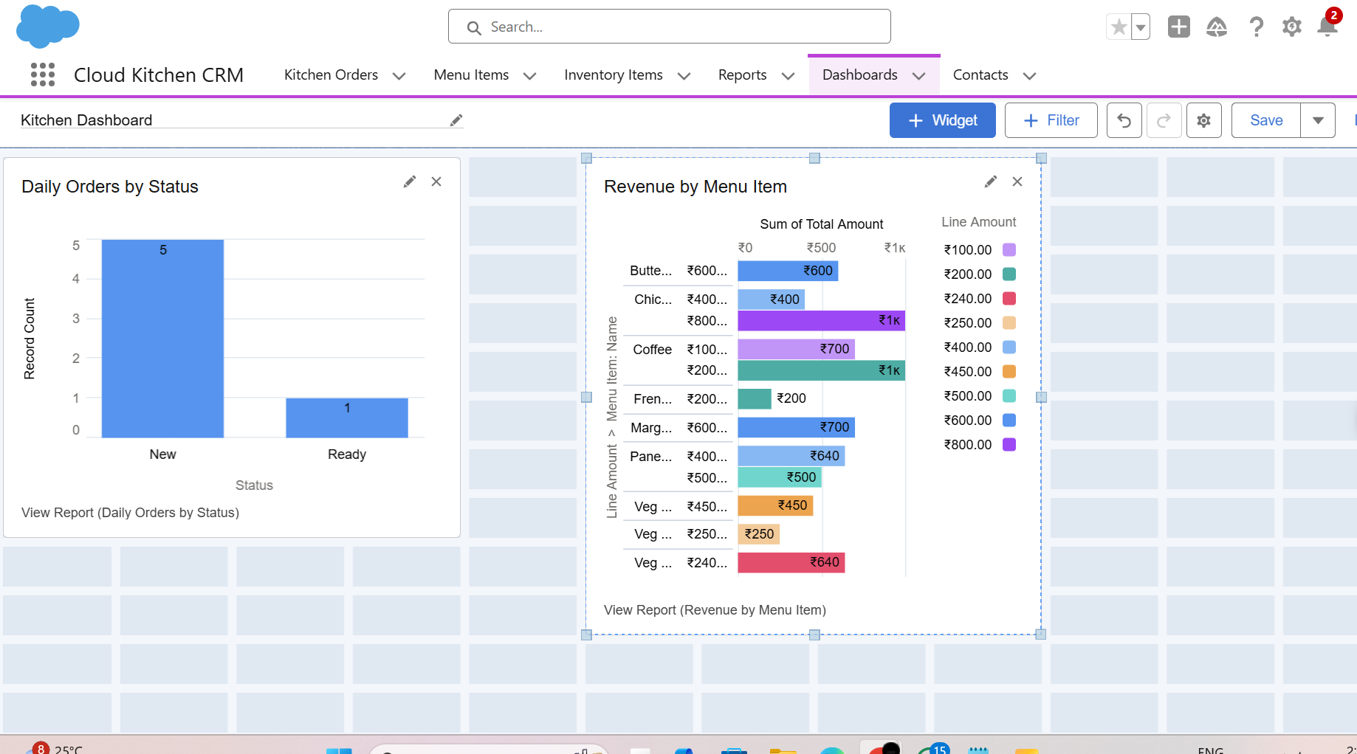

**Phase 9: Reporting, Dashboards & Security Review**

In this phase, the focus was on **strengthening the security of the Salesforce org** and ensuring **appropriate access for different types of users**. Proper configuration of profiles, roles, sharing rules, and field-level security ensures that sensitive data is protected while enabling users to perform their duties efficiently.

**Key Activities:**

1. **Profiles and Roles Configuration**
   * Created **Profiles** for different types of users: **Manager, Staff, Delivery**.
   * Assigned **roles** to users to control their visibility and access to records according to their position in the hierarchy.
   * Profiles define object-level permissions, tab visibility, and app access, ensuring that each user can only access the functionality relevant to their role.
   * 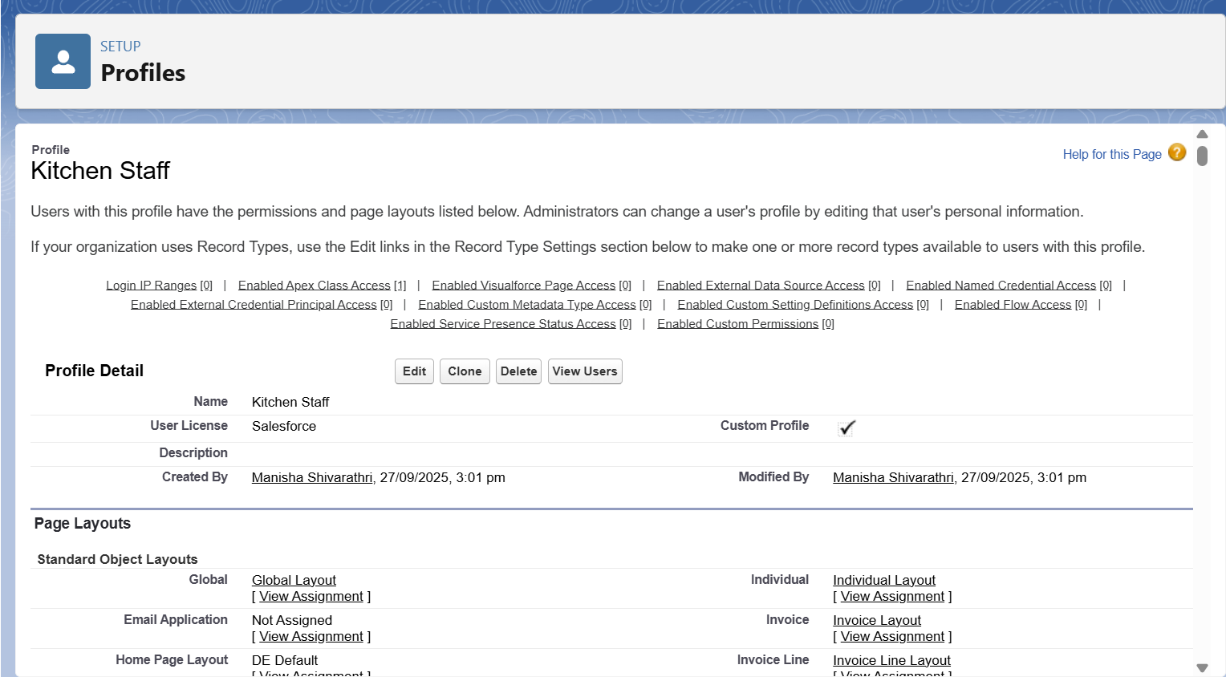
   * 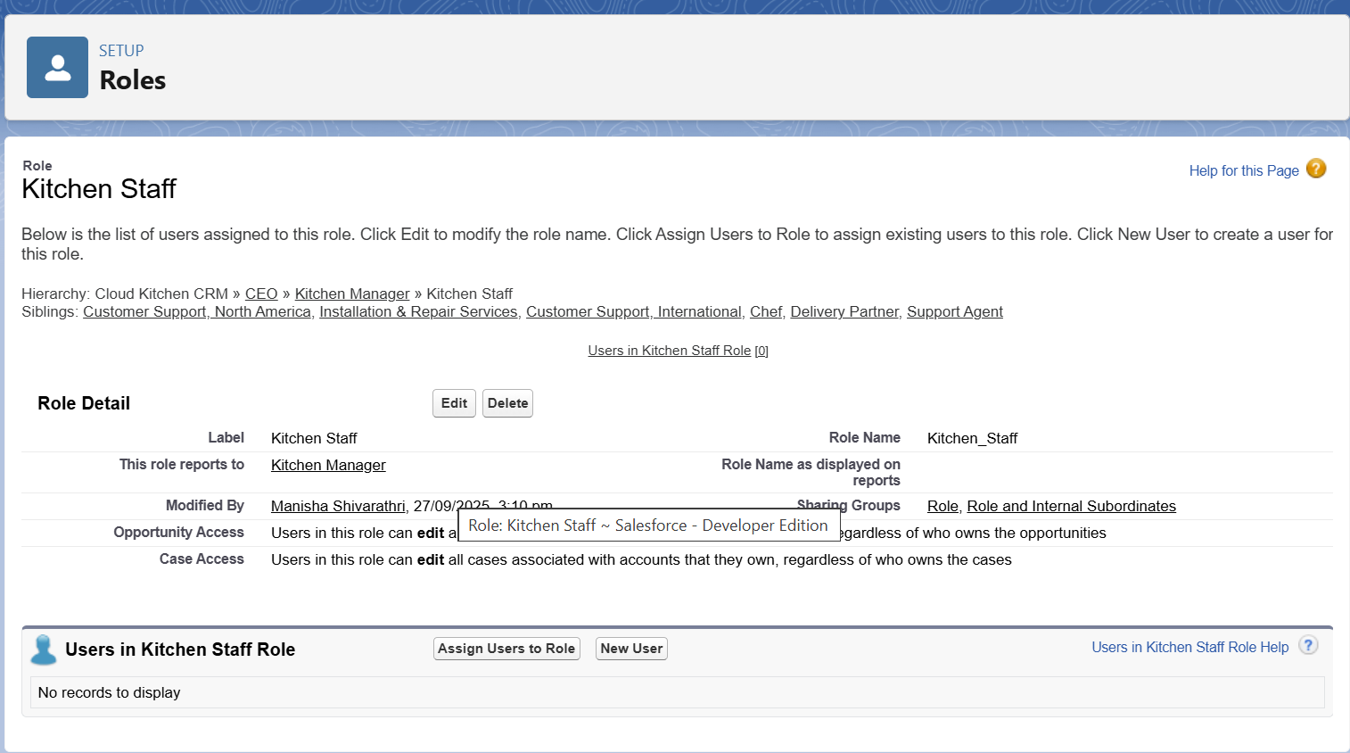
   * 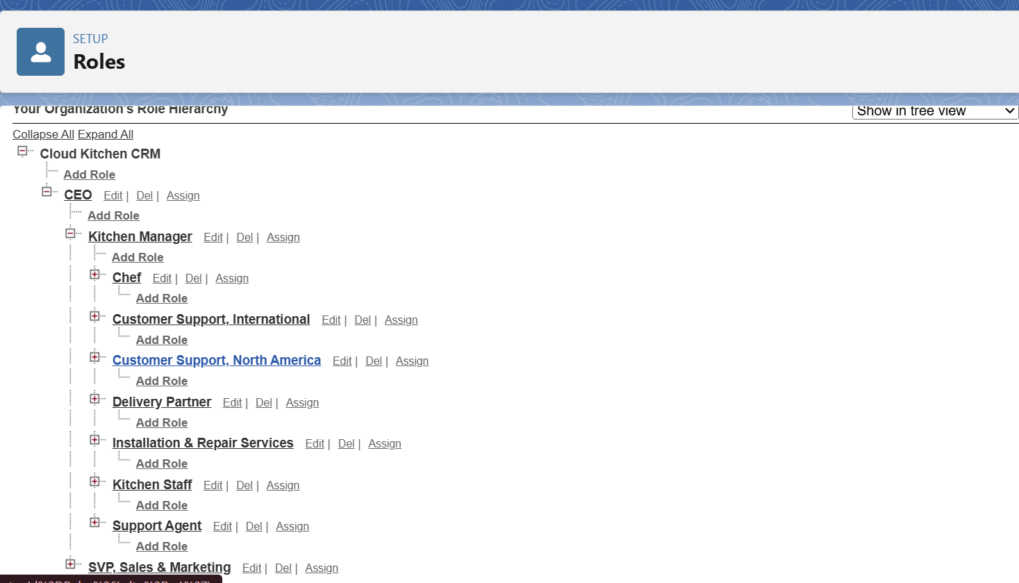
2. **Permission Sets**
   * Created **Permission Sets** to grant additional privileges, such as **Inventory access**, without changing the base profile.
   * This allows flexibility in granting temporary or specialized access without modifying core profiles.
   * 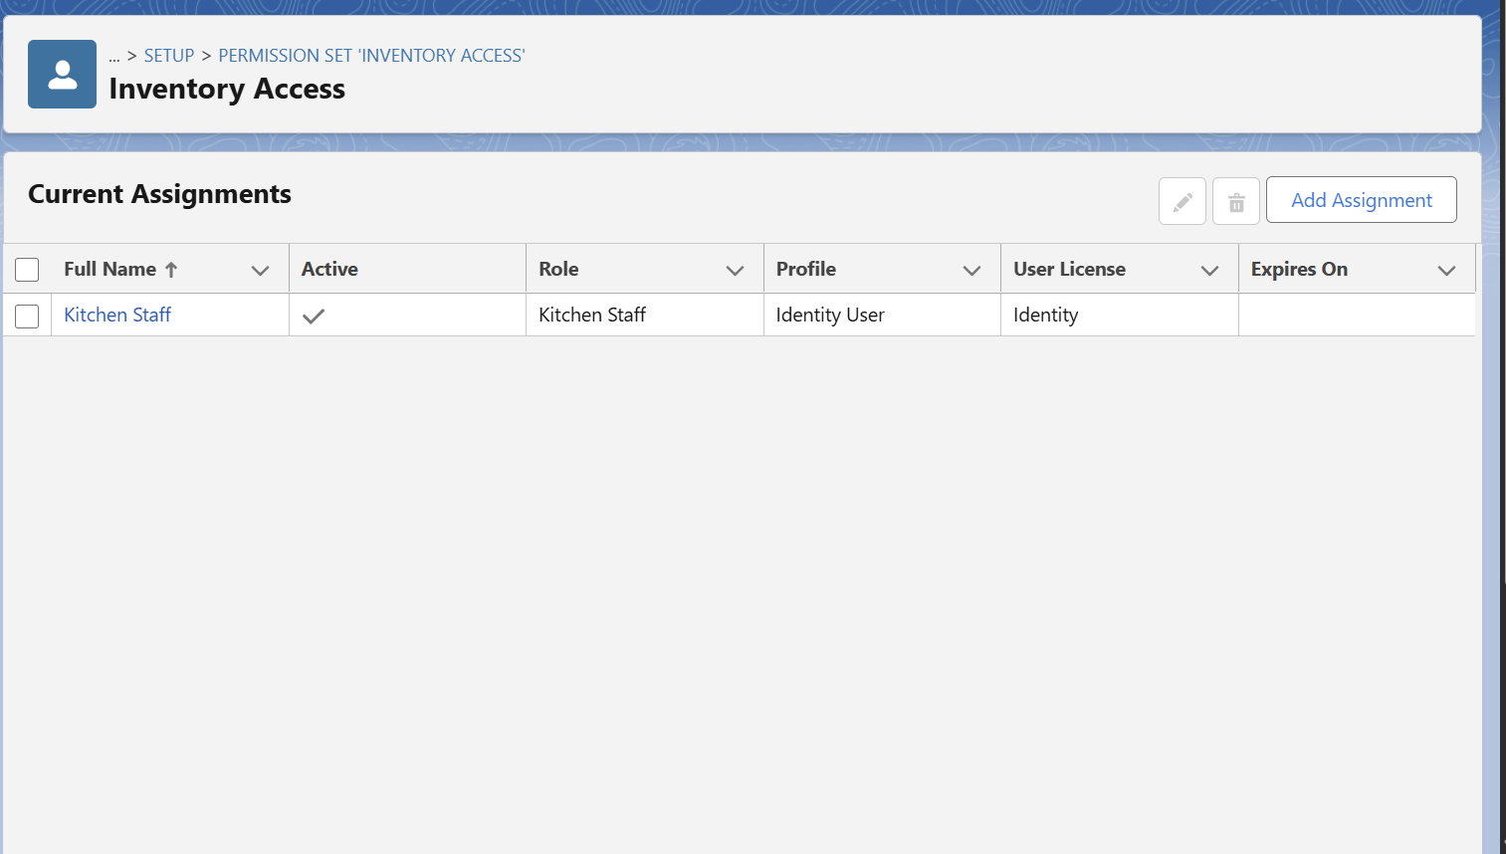
3. **Org-Wide Defaults (OWD)**
   * Configured **default sharing settings** for objects:
     + Orders = **Private** (users can see only their own orders unless shared)
     + Inventory/Menu = **Public Read-Only** (all users can view, but not edit)
   * Ensures sensitive transactional data is protected while essential information is visible to staff who need it.
   * 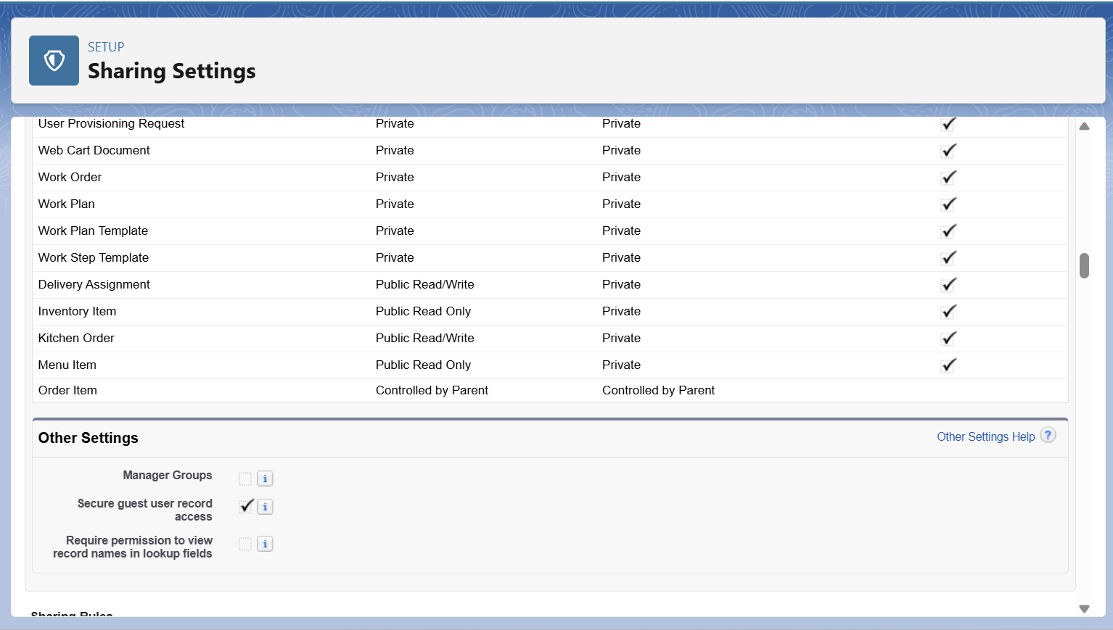
4. **Sharing Rules**
   * Created **criteria-based sharing rules** to automatically share records.
   * Example: Orders with **Status = Ready** are shared with **Delivery Staff**, enabling them to access only the orders they need to deliver.
   * Sharing rules complement OWD settings to provide secure but necessary record access.

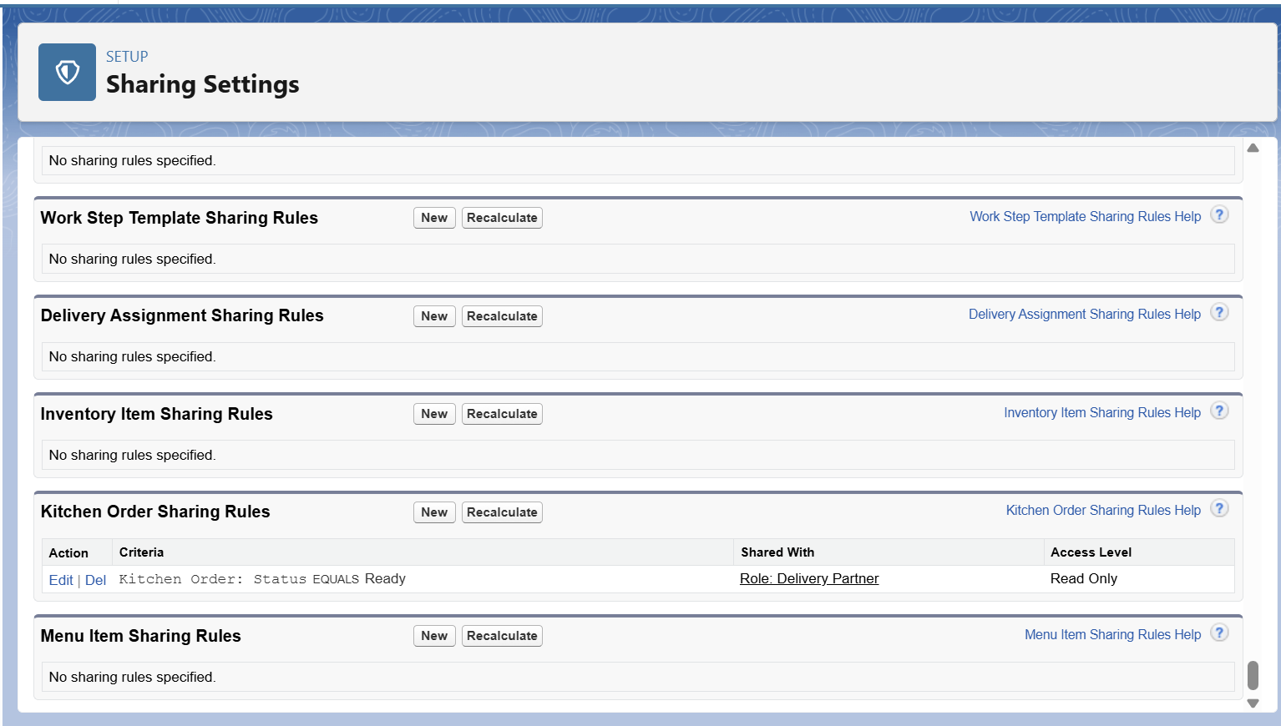

1. **Field-Level Security (FLS)**
   * Sensitive fields, such as **Cost Price**, were hidden from **Staff profile** to prevent unauthorized access.
   * Field-level security ensures that users can only view and edit fields appropriate to their role.
2. **Session Settings**
   * Configured **session timeout**, IP restrictions, and login settings to enhance security.
   * Helps protect the org from unauthorized access and enforces security policies.

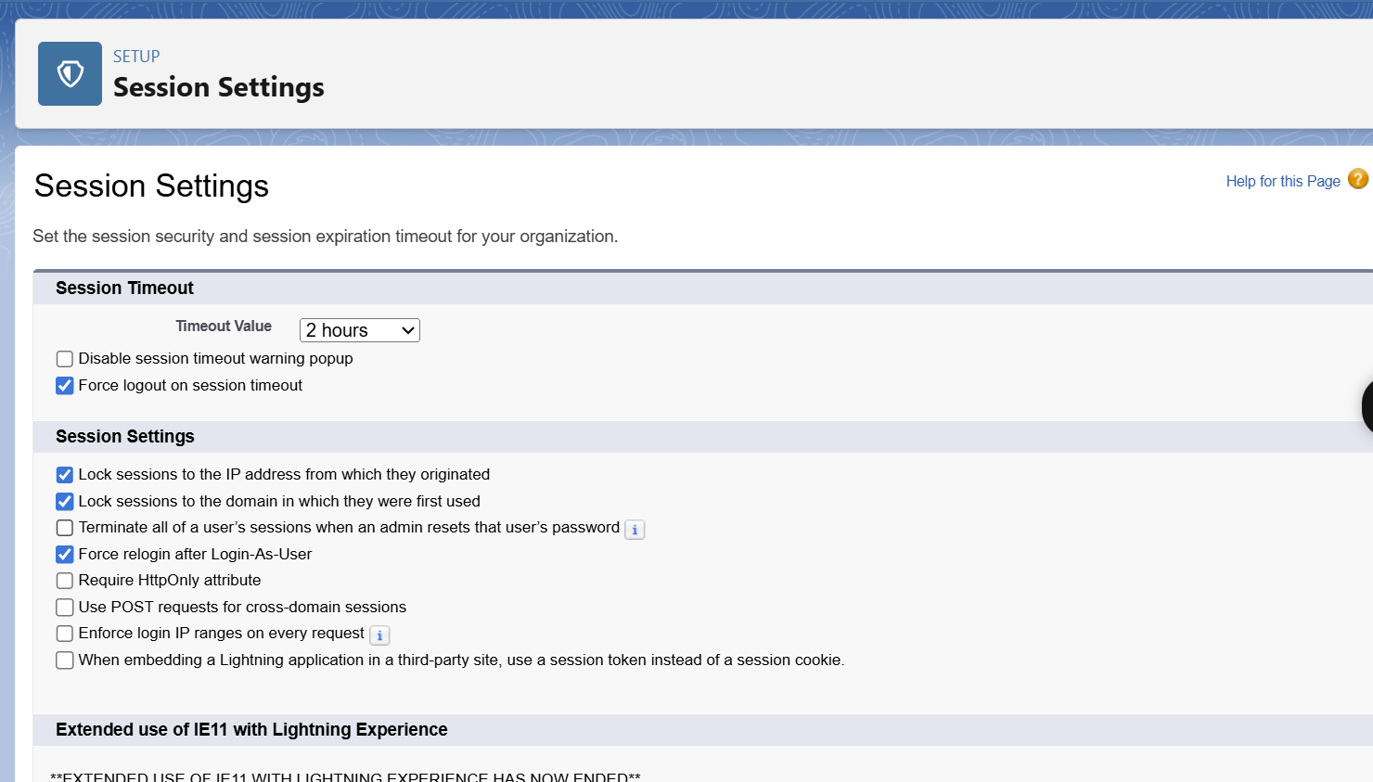

1. **Audit Trail Verification**
   * Reviewed the **Setup Audit Trail** to track configuration changes, ensuring transparency and accountability.
   * Audit logs confirm that all security settings were applied correctly.

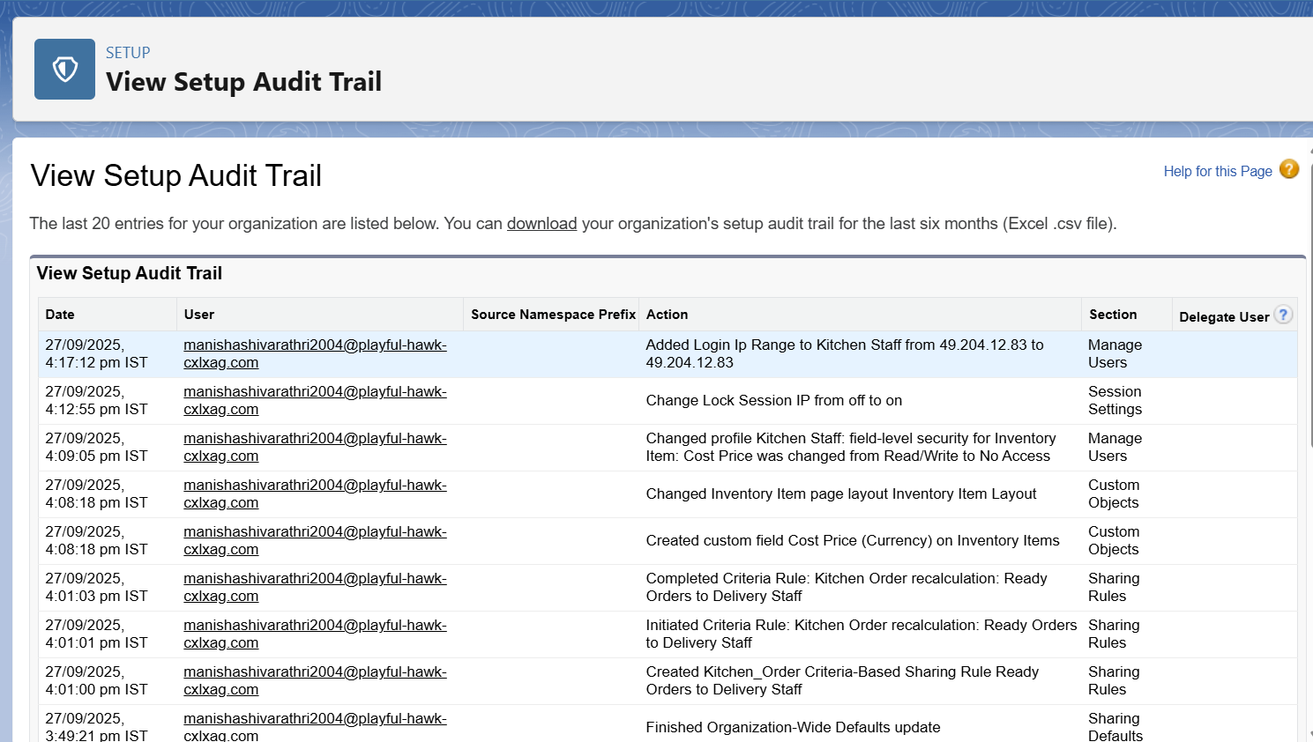

**Phase 10: Final Presentation & Conclusion**

The **Cloud Kitchen CRM project** demonstrates the practical application of Salesforce to manage a **comprehensive online food ordering system**. By leveraging Salesforce’s core features such as custom objects, automation, reporting, and security, the system streamlines operations and provides actionable insights for managers and staff.

**Key Benefits Achieved:**

1. **Automation of Order Management**
   * Orders and order items are processed efficiently using **Flows and Apex**, reducing manual intervention.
   * Total amounts for orders are automatically calculated, improving accuracy and saving time for kitchen staff and management.
2. **Data Accuracy with Validation Rules**
   * **Validation rules** ensure that all orders, menu items, and inventory data meet business requirements.
   * Prevents incomplete or inconsistent data entry, maintaining the integrity of the system.
3. **Reports & Dashboards for Insights**
   * Detailed **reports** track daily orders, revenue by menu item, and inventory status.
   * The **Kitchen Dashboard** provides a visual overview, enabling quick decision-making and performance monitoring.
4. **Security and Controlled Access**
   * Proper **profiles, roles, permission sets, and field-level security** ensure users can only access information relevant to their role.
   * Sensitive data such as cost price is protected, and record visibility is controlled via **sharing rules and org-wide defaults**.
5. **Scalable and Extensible System**
   * The project is ready for **demonstration and deployment**, with a foundation that allows future enhancements.
   * Potential extensions include **mobile apps, customer-facing portals, and integration with third-party delivery services or payment gateways**.

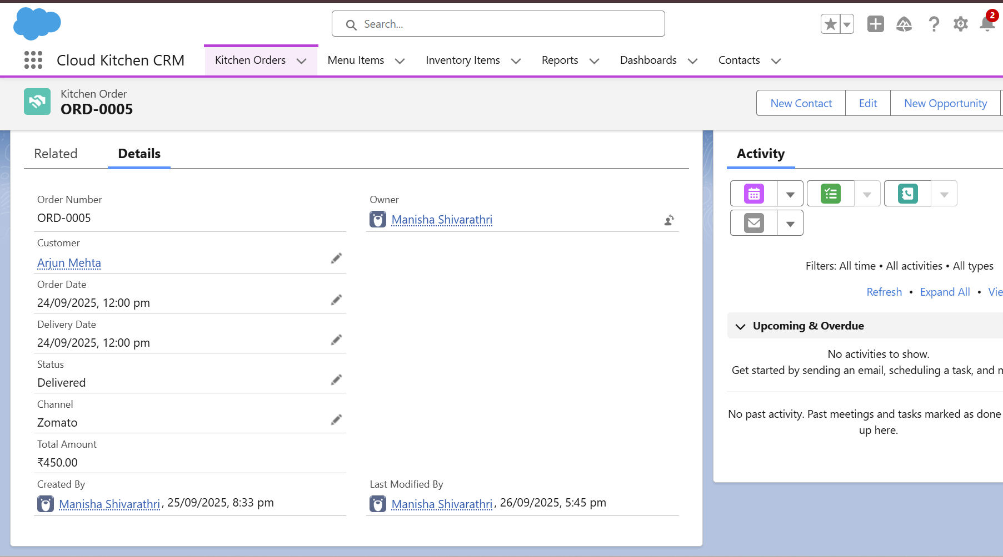

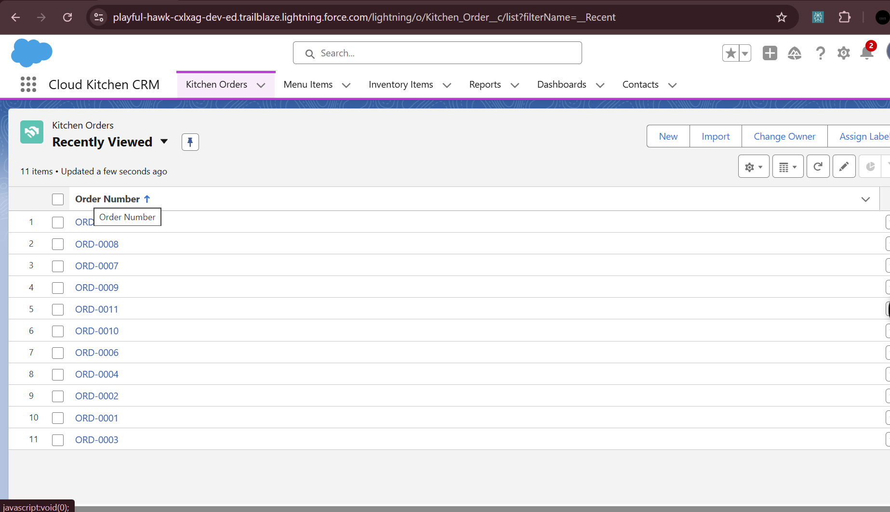

**Conclusion**

The Cloud Kitchen CRM project demonstrates how Salesforce can streamline order management, ensure data accuracy, and provide actionable insights through reports and dashboards. With robust security and automation in place, the system is ready for deployment and can be extended in the future with mobile apps, customer portals, and third-party integrations.